**Web Application Penetration Testing**

1. **Broken Authentication / Authentication Vulnerabilities.**

* Authentication vulnerabilities are usually critical because of the clear relationship between authentication and security.
* Authentication vulnerabilities can allow attackers to gain access to sensitive data and functionality. They also expose additional attack surface for further exploits. For this reason, it's important to learn how to identify and exploit authentication vulnerabilities, and how to bypass common protection measures.

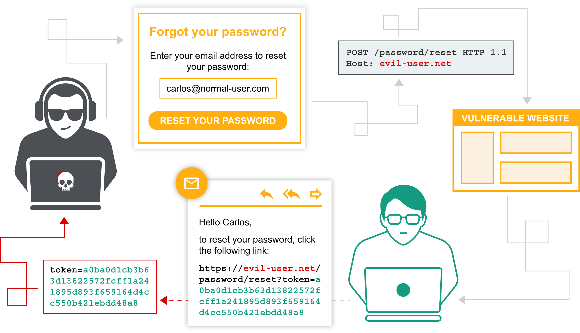

1. What is authentication?

* Authentication is the process of verifying the identity of a user or client. Websites are potentially exposed to anyone who is connected to the internet. This makes robust authentication mechanisms integral to effective web security.

1. We have three main types of authentications

* Something you **know**, such as a Password or the answer to a security question. These are sometimes called "knowledge factors".
* Something you **have**, this is a physical object such as A mobile phone or security token. These are sometimes called "possession factors".
* Something you **are** or do. For example, your biometrics or patterns of behaviour. These are sometimes called "inherence factors".

1. What is the difference between authentication and authorization?

* Authentication determines whether someone attempting to access a website with the username example like “Carlos” really is the same person who created the account.
* Once “Carlos” is authenticated, their permissions determine what they are authorized to do. For example, they may be authorized to access personal information about other users, or perform actions such as deleting another user's account.

1. How do authentication vulnerabilities arise?

Most vulnerabilities in authentication mechanisms occur in one of two ways:

* The authentication mechanisms are weak because they fail to adequately protect against brute-force attacks.
* Logic flaws or poor coding in the implementation allow the authentication mechanisms to be bypassed entirely by an attacker. This is sometimes called "broken authentication".

1. What is the impact of vulnerable authentication?

* The impact of authentication vulnerabilities can be severe. If an attacker bypasses authentication or brute-forces their way into another user's account, they have access to all the data and functionality that the compromised account has. If they are able to compromise a high-privileged account, such as a system administrator, they could take full control over the entire application and potentially gain access to internal infrastructure
* Even compromising a low-privileged account might still grant an attacker access to data that they otherwise shouldn't have, such as commercially sensitive business information. Even if the account does not have access to any sensitive data, it might still allow the attacker to access additional pages, which provide a further attack surface. Often, high-severity attacks are not possible from publicly accessible pages, but they may be possible from an internal page.

1. Vulnerabilities in authentication mechanisms

* Vulnerabilities in password-based login
* Vulnerabilities in multi-factor authentication
* Vulnerabilities in other authentication mechanisms

# Vuln 1:Vulnerabilities In password-based logins

1. For websites that adopt a password-based login process, users either register for an account themselves or they are assigned an account by an administrator. This account is associated with a unique username and a secret password, which the user enters in a login form to authenticate themselves.
2. if an attacker is able to either obtain or guess the login credentials of another user.
3. This can be achieved in a number of ways.

# Methods: 1. Brute-force attacks

* A brute-force attack is when an attacker uses a system of trial and error to guess valid user credentials. These attacks are typically automated using wordlists of usernames and passwords. Automating this process, especially using dedicated tools, potentially enables an attacker to make vast numbers of login attempts at high speed.
* Websites that rely on password-based login as their sole method of authenticating users can be highly vulnerable if they do not implement sufficient brute-force protection.
  1. **Brute-forcing usernames**
* Usernames are especially easy to guess, for example, it is very common to see business logins in the format [firstname.lastname@somecompany.com](mailto:firstname.lastname@somecompany.com).
* An attacker can create sometimes even high-privileged accounts are created using predictable usernames, such as admin or administrator.
* During auditing, check whether the website discloses potential usernames publicly. For example, are you able to access user profiles without logging in? Even if the actual content of the profiles is hidden, the name used in the profile is sometimes the same as the login username. You should also check HTTP responses to see if any email addresses are disclosed. Occasionally, responses contain email addresses of high-privileged users, such as administrators or IT support.
* We can find IDORS, in robots.txt
  1. **Brute-forcing passwords**
* Passwords can similarly be brute-forced, with the difficulty varying based on the strength of the password. Many websites adopt common policy, which forces users to create high-entropy passwords, theoretically at least, harder to crack using brute-force alone. This typically involves enforcing passwords with:
  + A minimum number of characters.
  + A mixture of lower and uppercase letters.
  + At least one special character.
  1. **Username enumeration**
* Username enumeration is when an attacker is able to observe changes in the website's behaviour in order to identify whether a given username is valid.
* Username enumeration typically occurs either on the login page, for example, when you enter a valid username but an incorrect password, or on registration forms when you enter a username that is already taken. This greatly reduces the time and effort required to brute-force a login because the attacker is able to quickly generate a shortlist of valid usernames.
* Things we kept in mind While attempting to brute-force a login page, we should particularly pay attention to any differences in:
  1. **Status codes**: During a brute-force attack, the returned HTTP status code is likely to be the same for the vast majority of guesses because most of them will be wrong. If a guess returns a different status code, this is a strong indication that the username was correct.
  2. **Error messages**: Sometimes the returned error message is different depending on whether both the username AND password are incorrect or only the password was incorrect. It is best practice for websites to use identical, generic messages in both cases, but small typing errors sometimes creep in. Just one character out of place makes the two messages distinct, even in cases where the character is not visible on the rendered page.
  3. **Response times:** If most of the requests were handled with a similar response time, any that deviate from this suggest that something different was happening behind the scenes. This is another indication that the guessed username might be correct. For example, a website might only check whether the password is correct if the username is valid. This extra step might cause a slight increase in the response time. This may be subtle, but an attacker can make this delay more obvious by entering an excessively long password that the website takes noticeably longer to handle.

# Methods: 1. Lab: 1. Username enumeration via different responses

[**https://portswigger.net/web-security/authentication/password-based/lab-username-enumeration-via-different-responses**](https://portswigger.net/web-security/authentication/password-based/lab-username-enumeration-via-different-responses)

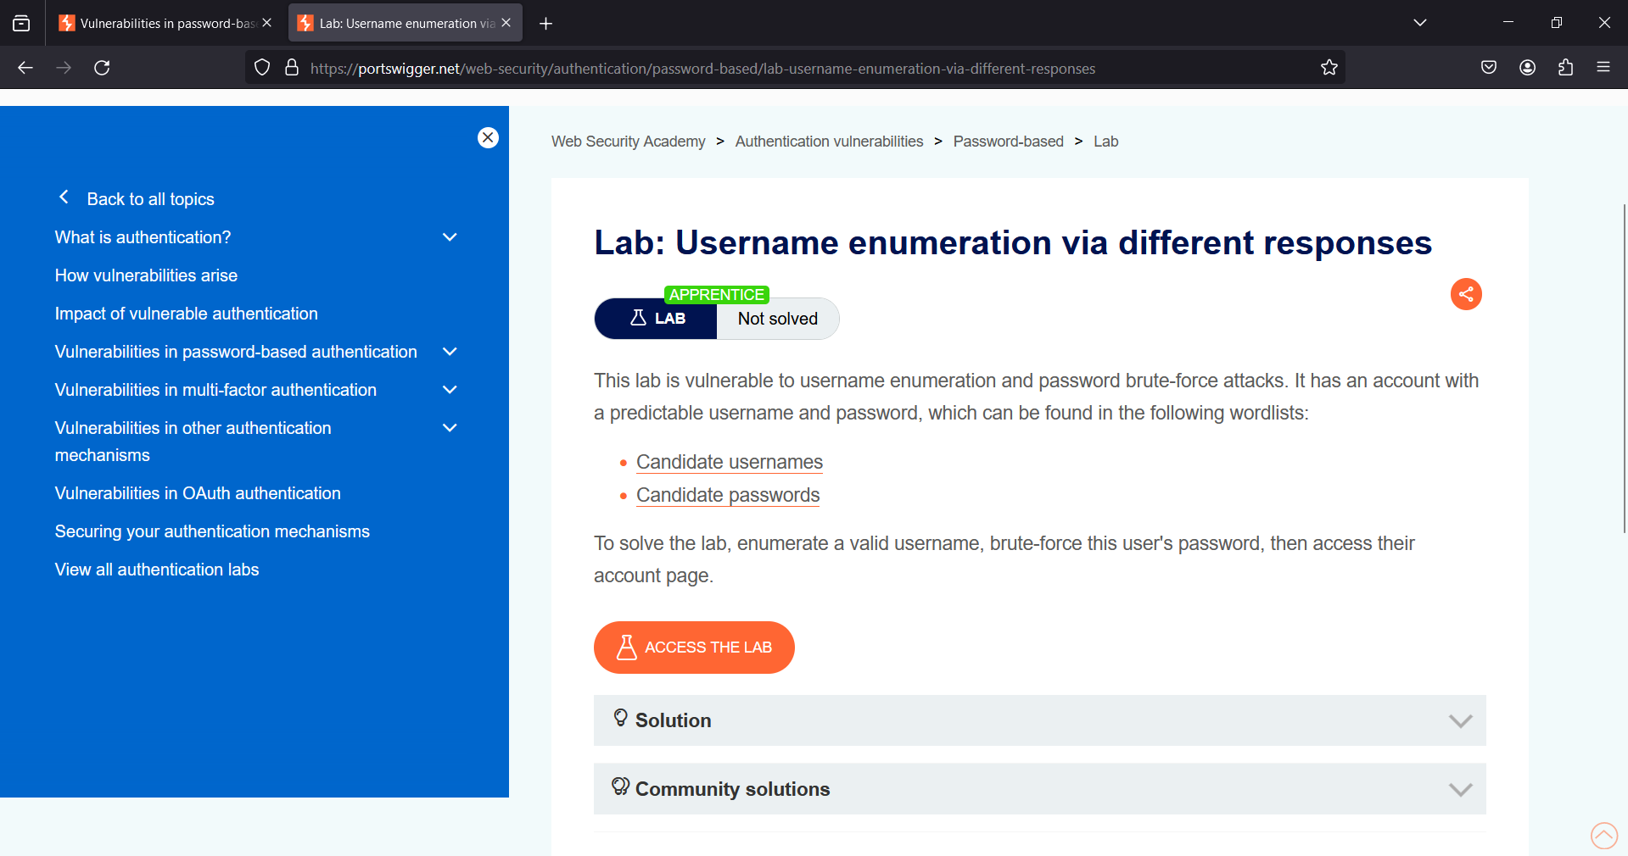

We have password and username provided this website is vulnerable to brute force attack.

**Let Access the Lab**

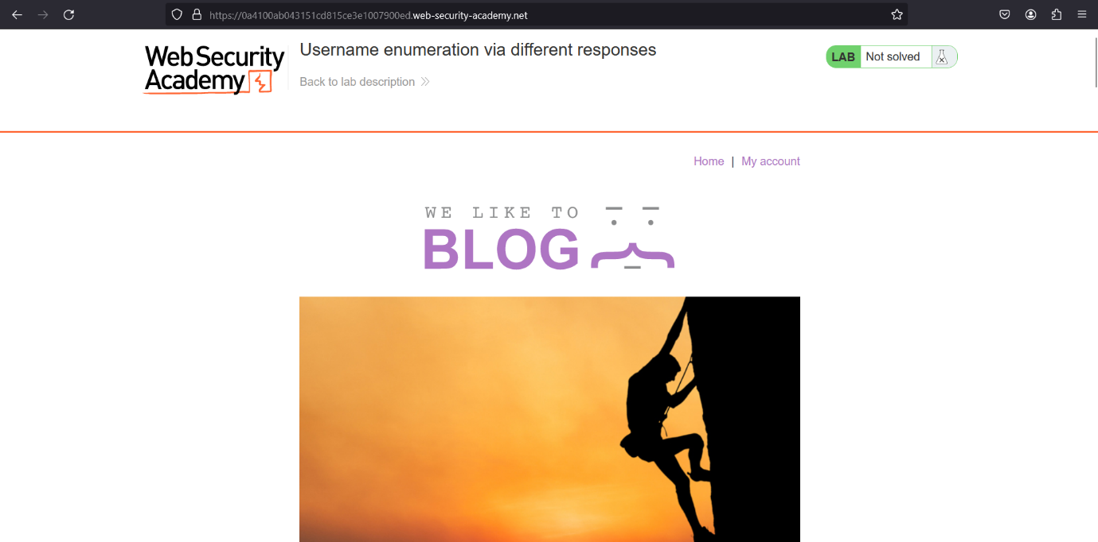

Go to My Account

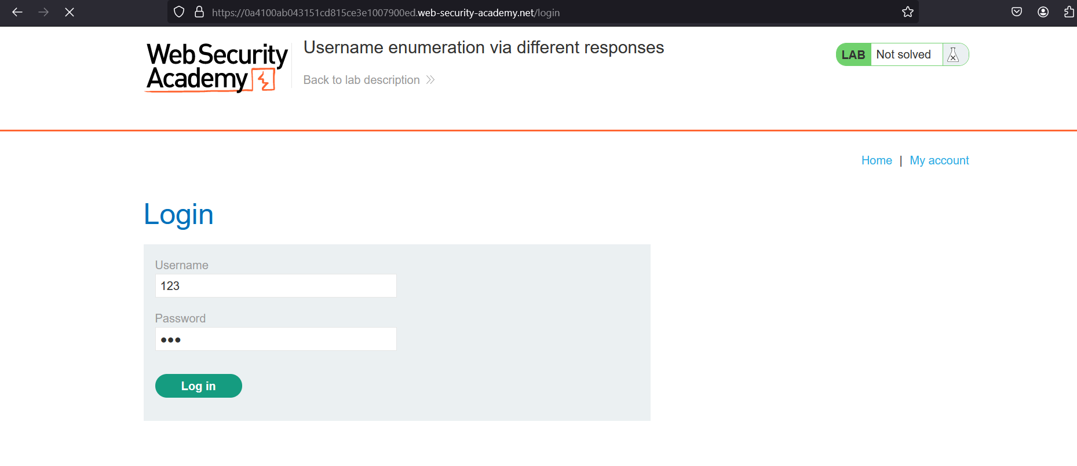

Open Burp > Intercept On > capture request

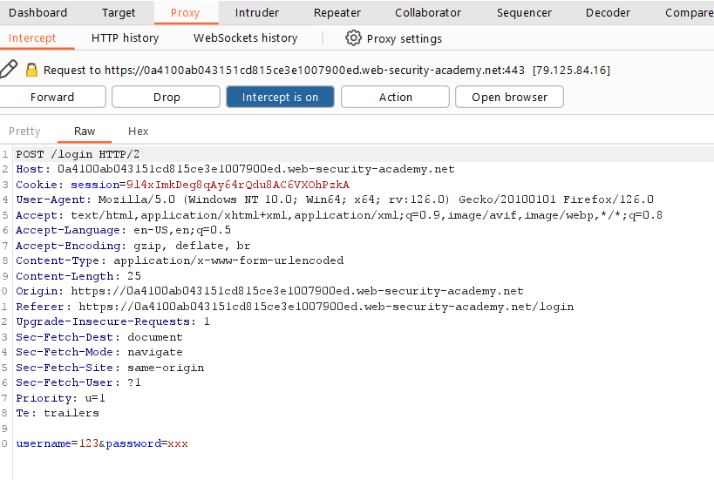

Send this to Intruder > Add $ to username position

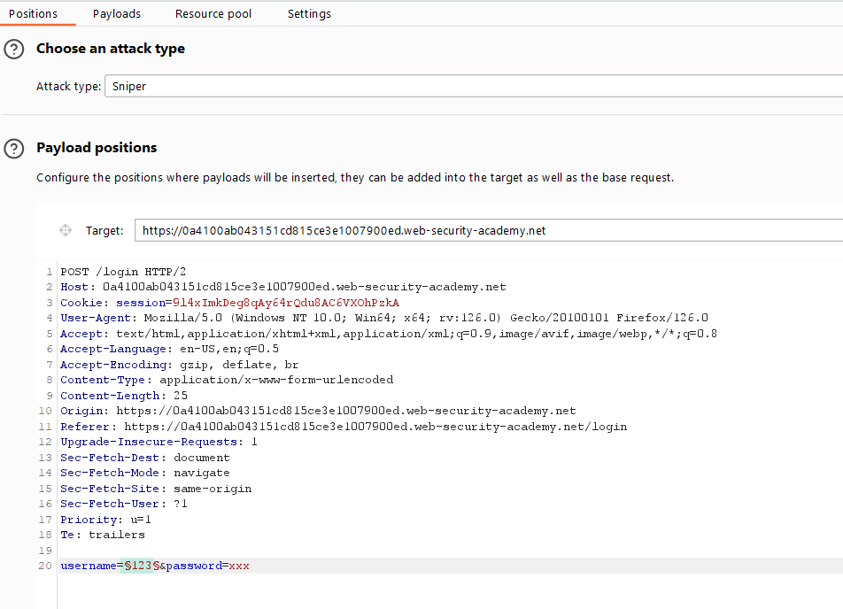

Now Let add payload

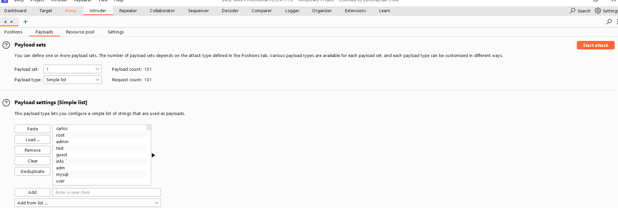

**Start attack**

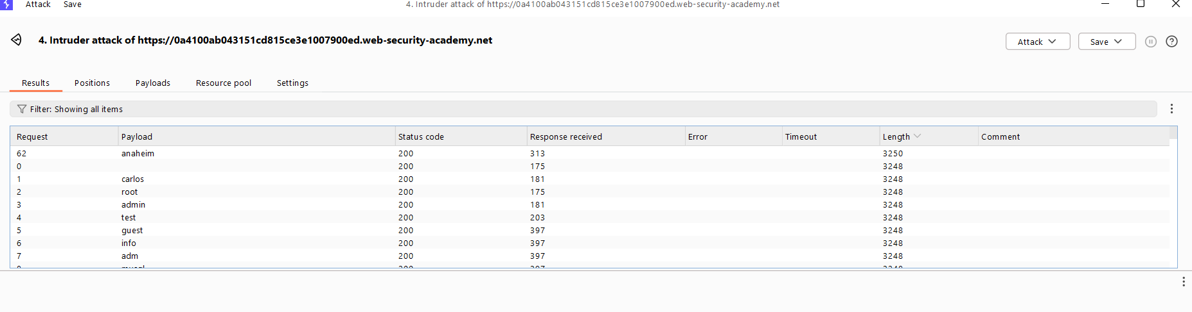

If we see the **difference in length**

So, the valid username is “anaheims**”**

Now same goes to password > copy password wordlists

Add $ to password position and clear username position.

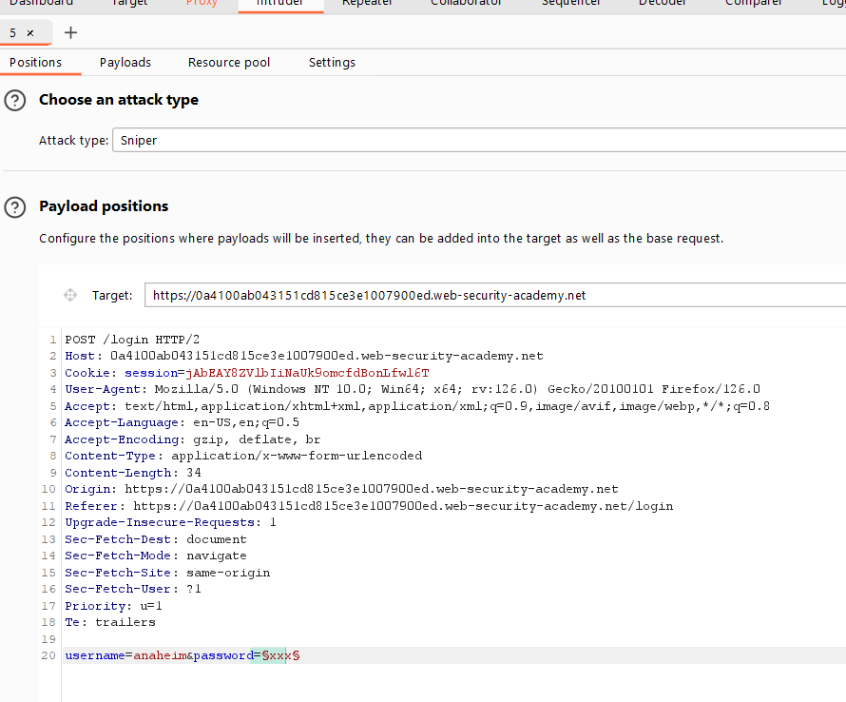

Now go to payloads

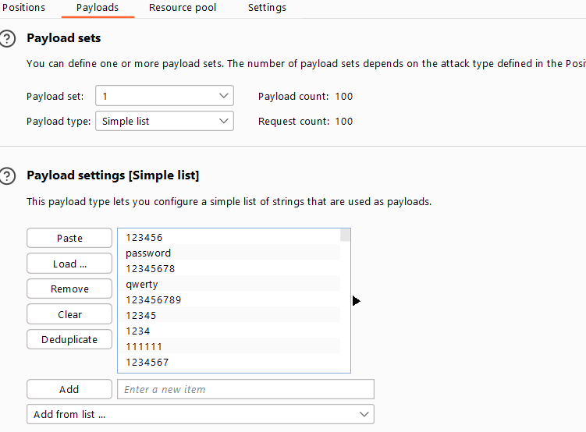

**Start attack**

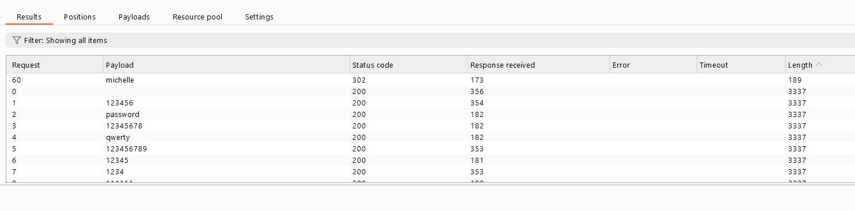

We can see **difference in length** mean this password is valid “”

So, we can login with this password “Michelle**”**

**Let request this in current browser**

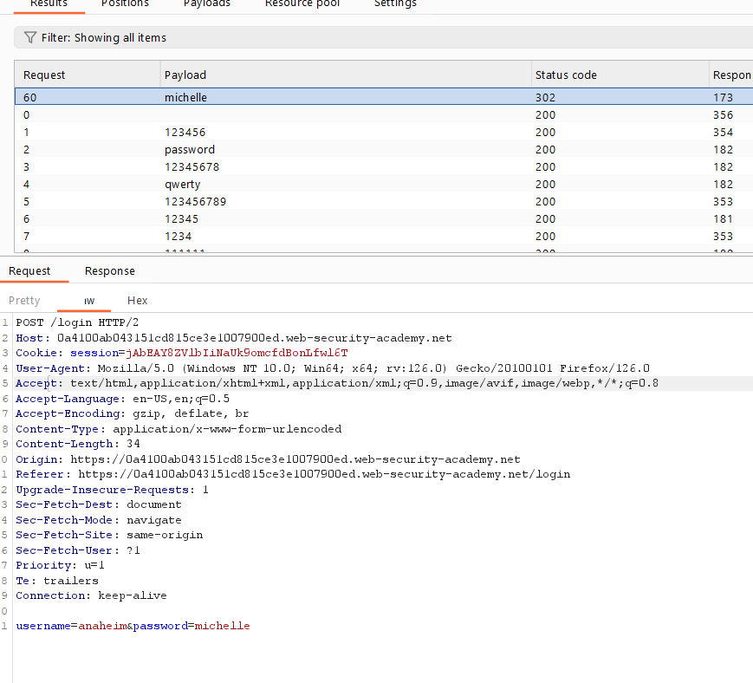

**Right click on request**

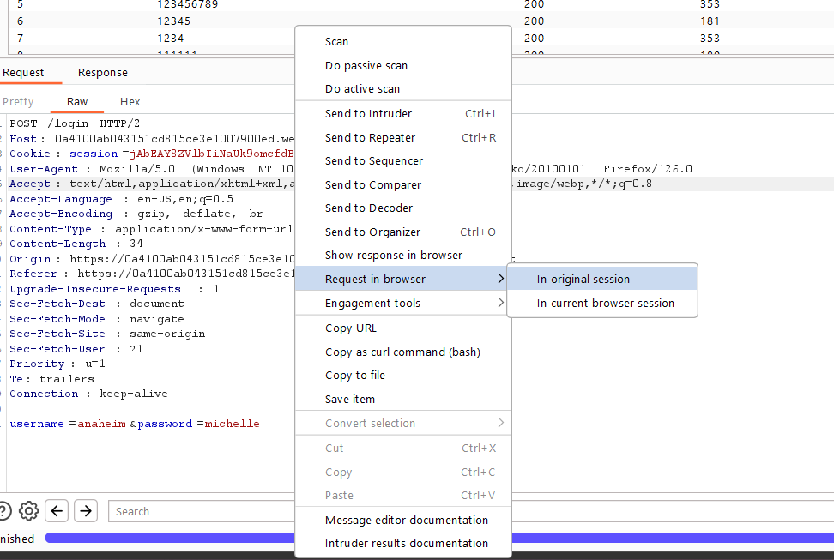

Send request in original Session > drop all request of intercept

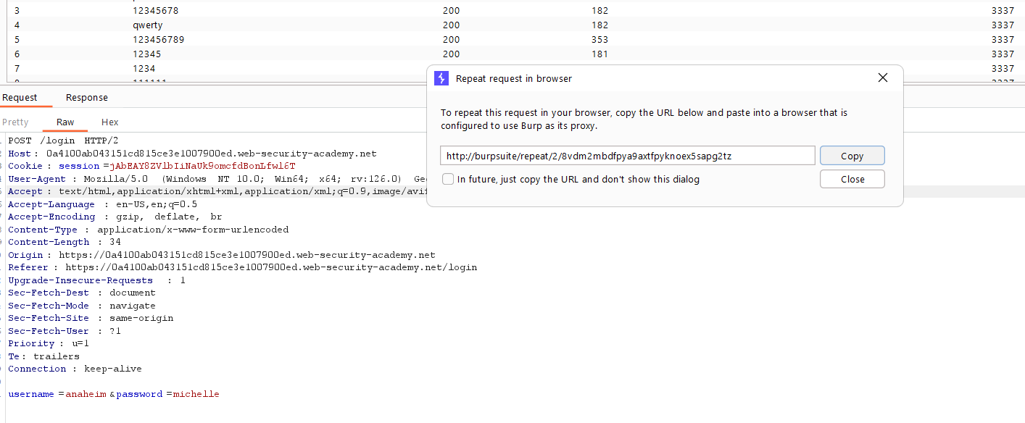

**Copy URL > past in browser**

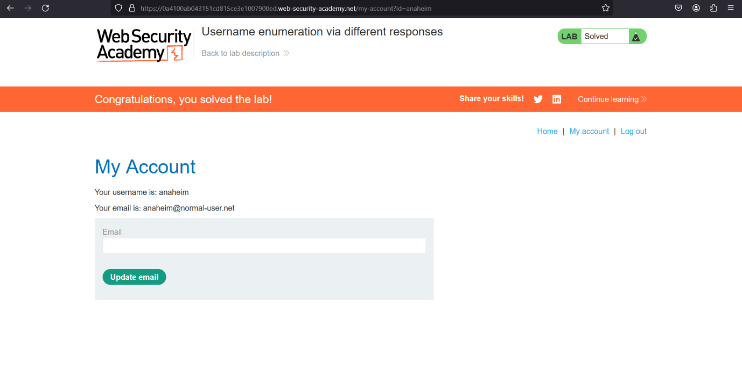

The main motive of this lab we can see a valid username have a difference in length that help us to identify easily which username and password is valid.

But we can do this in easier way, to save time if we know user and pass > Just go to Intruder again > Add $ to user and pass position

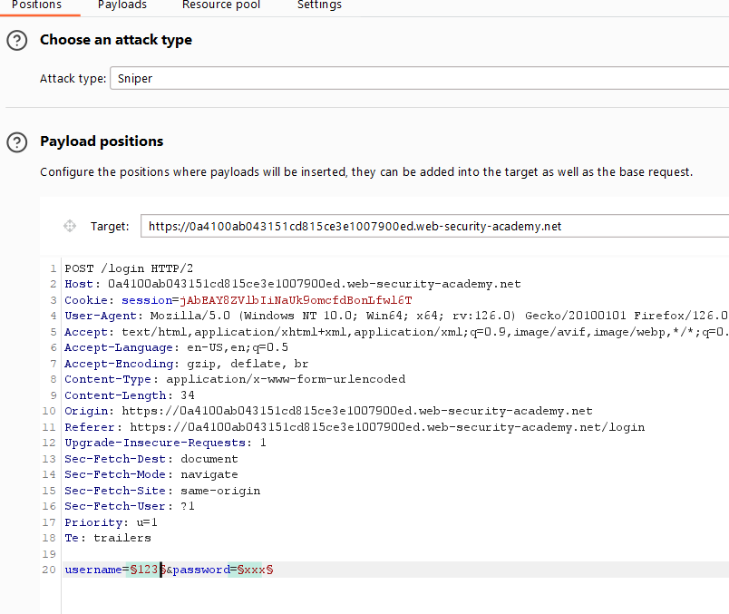

Switch Attack type > sniper to cluster bomb

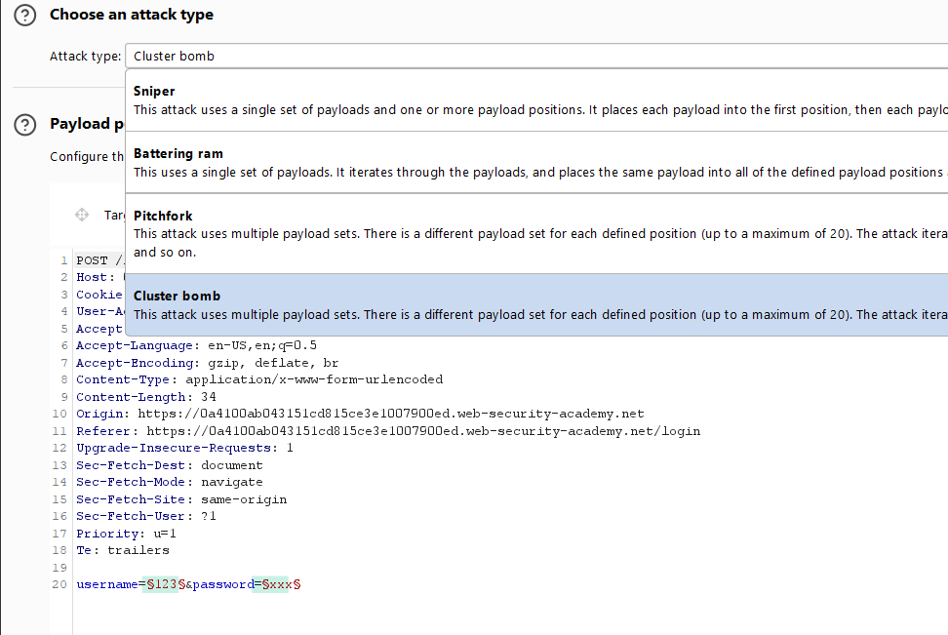

Go To payloads

Clear old > add user list

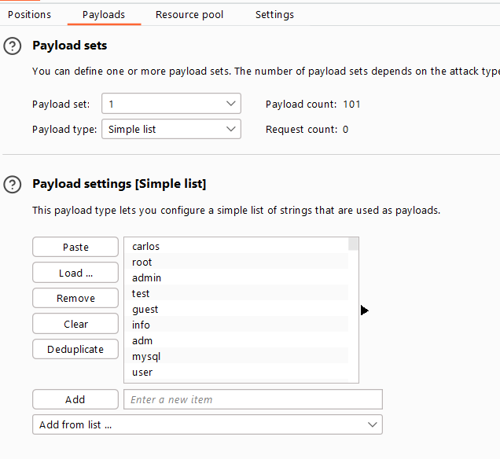

Got to payload set > change it to 2 > add password list

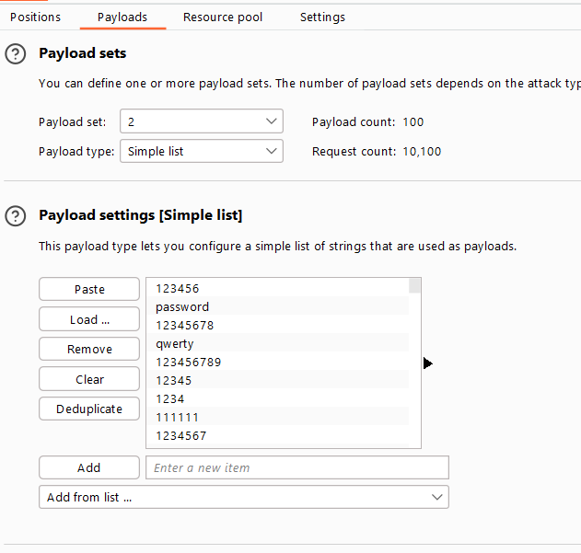

**Start Attack**

Cluster bomb allows us to brute force at two locations at 1 once

**Let move to next ….**

# Methods: 1. Lab: 2. Username enumeration via subtly different responses

<https://portswigger.net/web-security/authentication/password-based/lab-username-enumeration-via-subtly-different-responses>

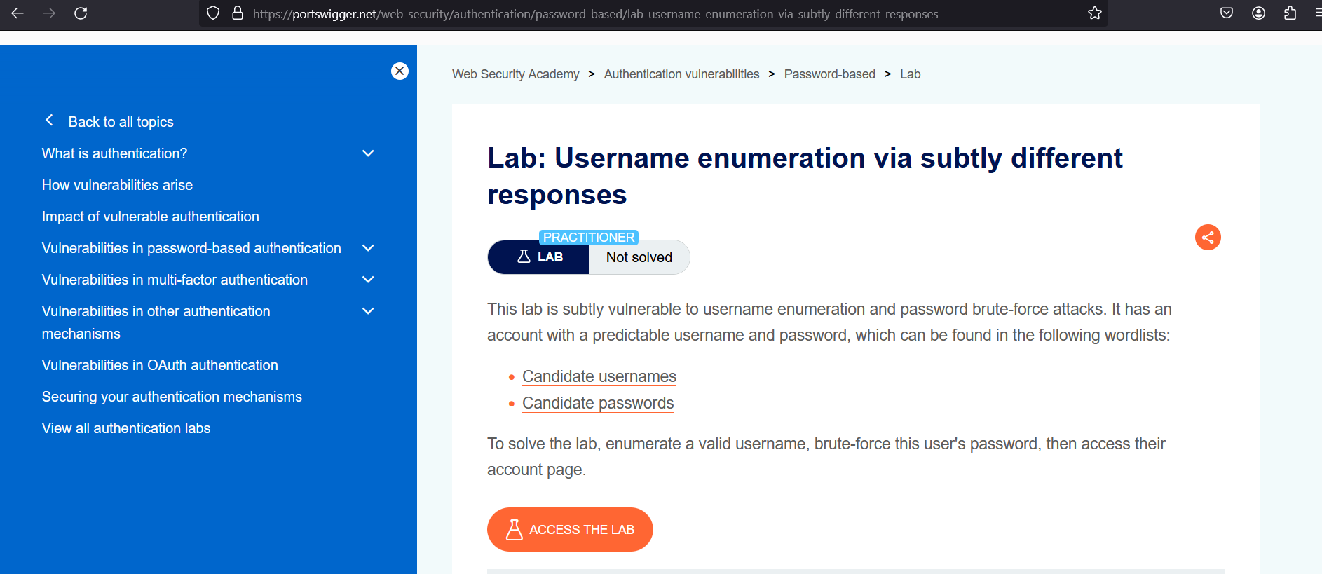

**In This lab scenario If we repeat the same process as last lab**

**We simply couldn’t find the correct username bez there are multiple names showing same length.**

**Let do it**

**Open the lab**

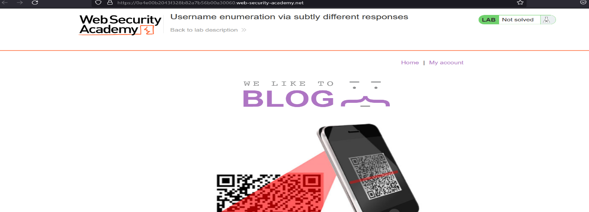

**go to my account > login with random character**

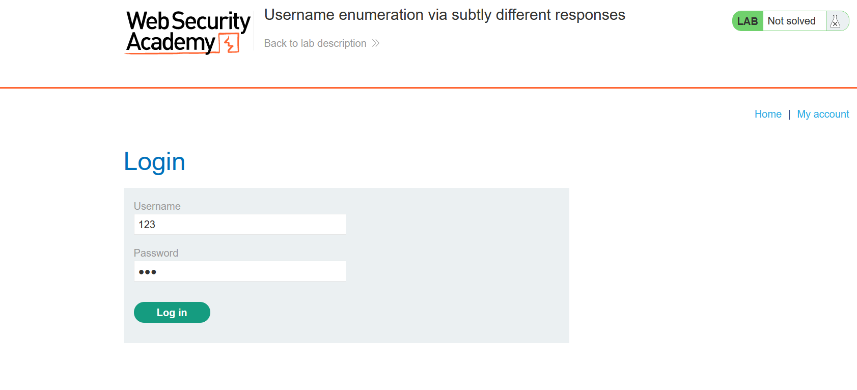

**Capture the request**

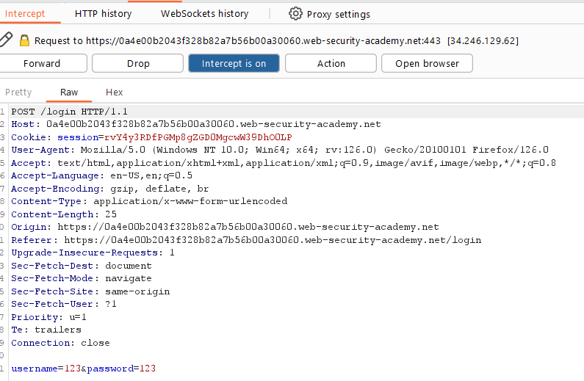

**Send to Intruder > add $ at username**

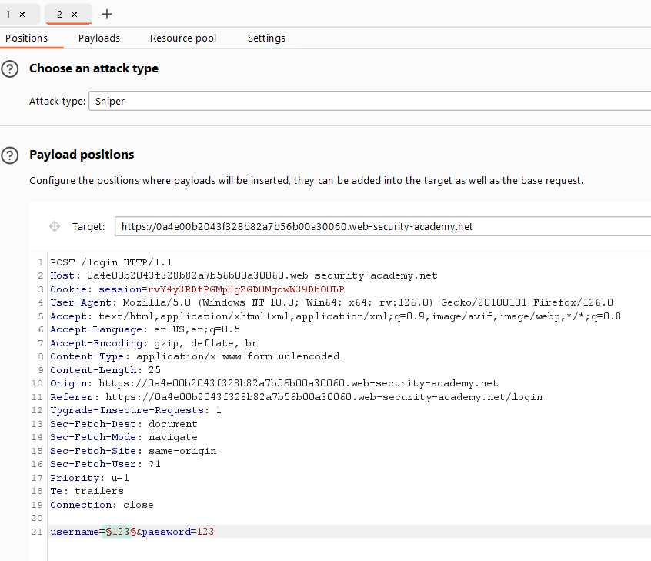

**Add wordlist**

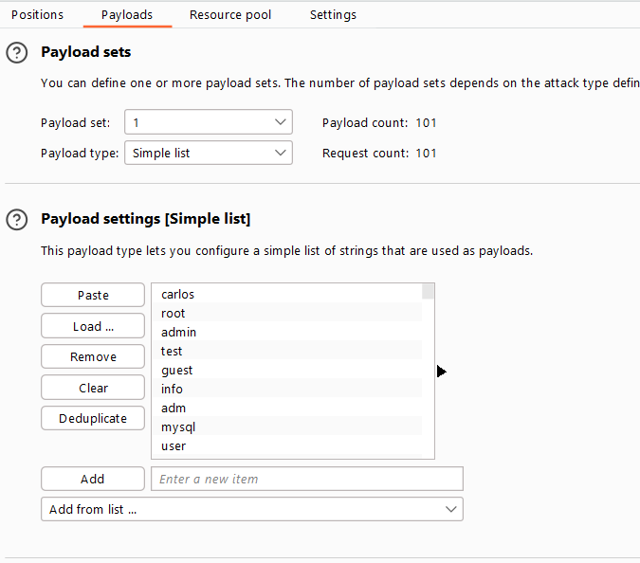

**Start Attacks**

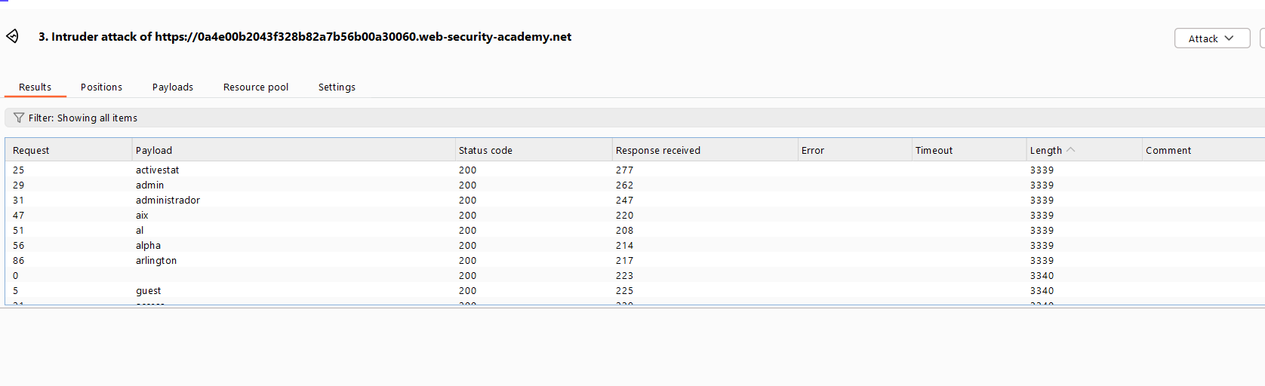

**Now here we can see there are more than username have different length**

**So basic Question is how?**

**The 1St method is**

**So just go to SETTNGS**

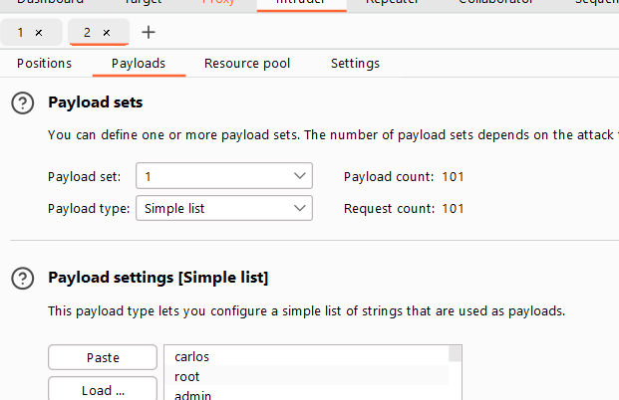

**Open settings**

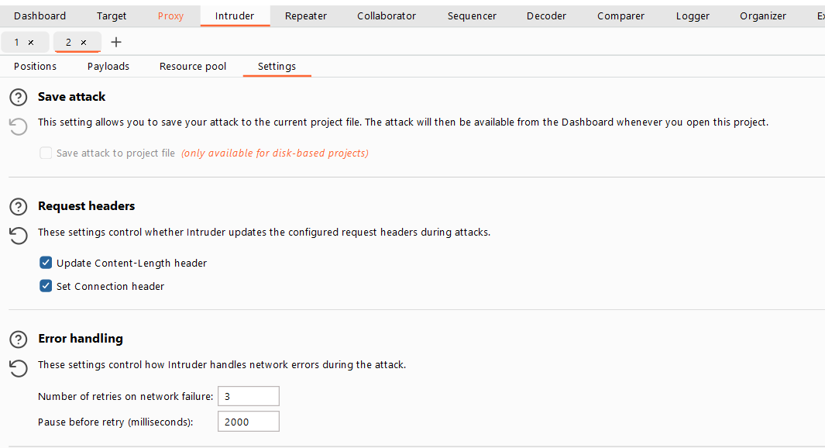

**Scroll Down**

**Find > Grep – Extract** > click **Add**

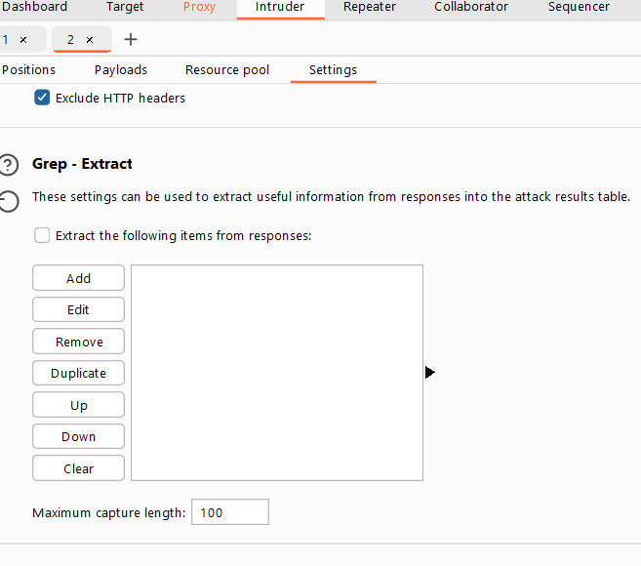

**Add “**Invalid username or password**”**

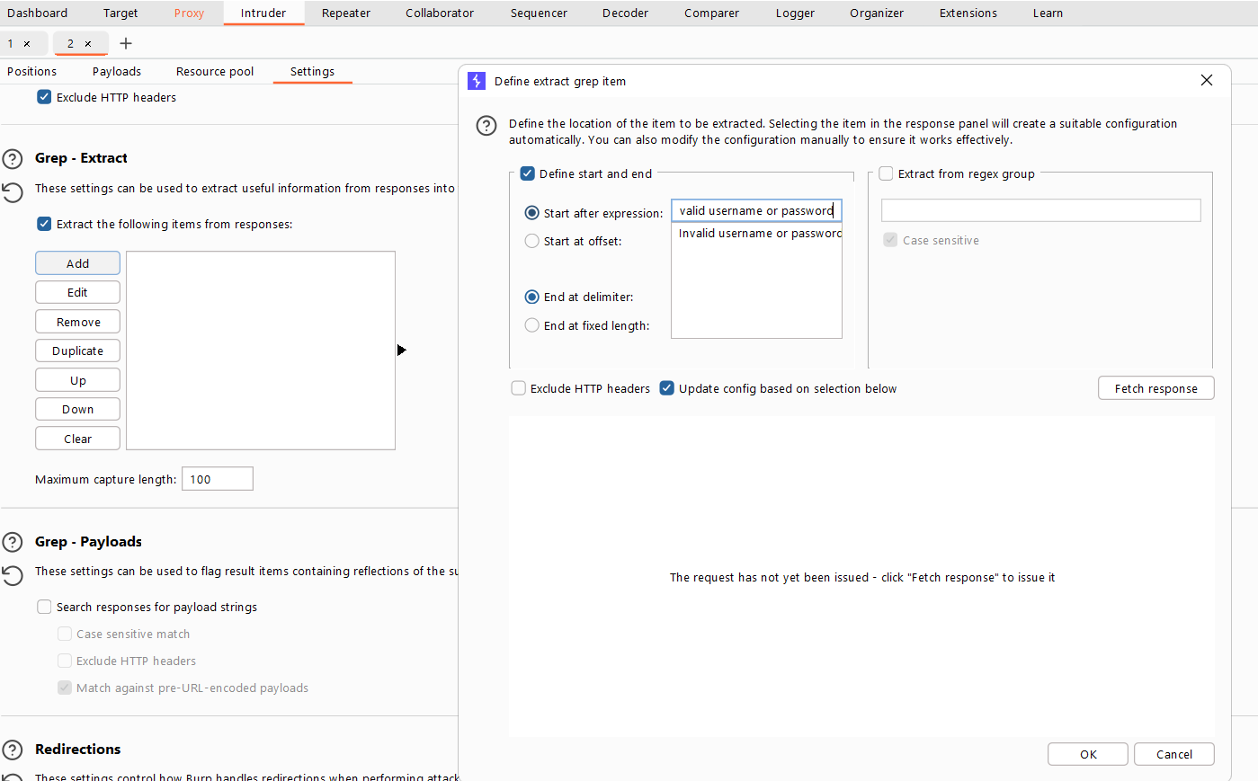

Ok

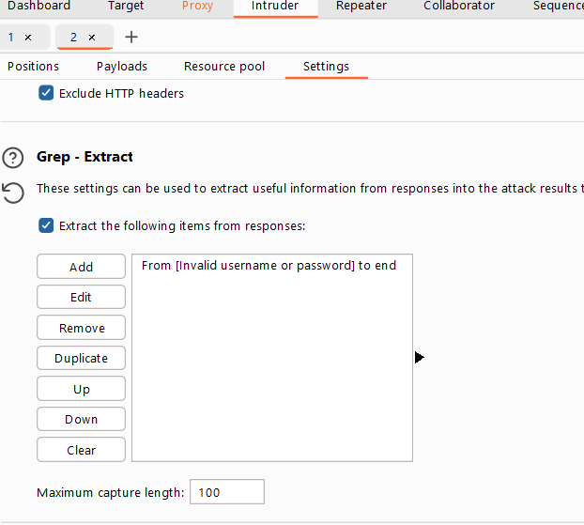

Start Attack

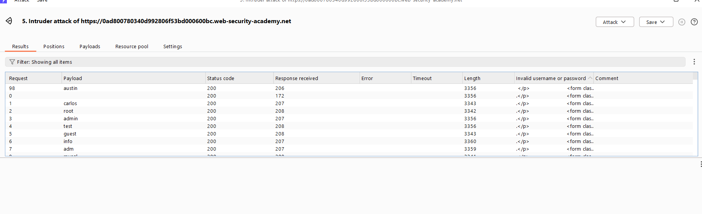

We got username “austin”

So The basic question comes

Why we adding this syntax we are checking any attempt of brute force have this “Invalid username or password” keyword or not

How we got this keyword

Bez

If we type an incorrect user pass it show us

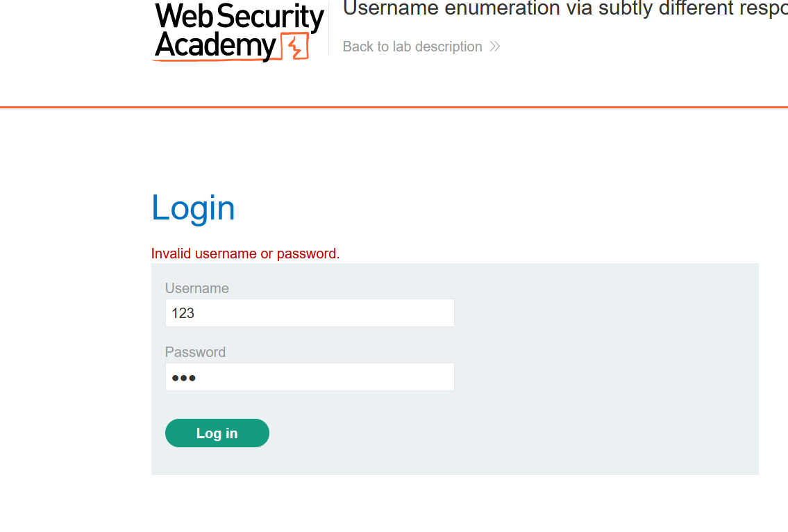

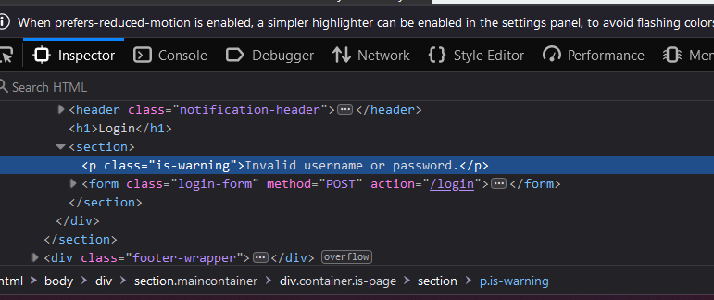

Let Brute password

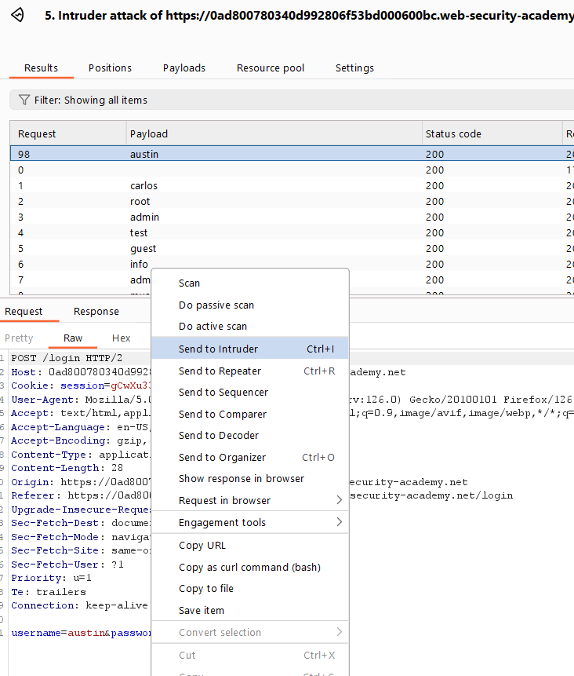

Send this new Request to Intruder remember that keyword we added to find username we no longer need that if u add that keyword in password it didn’t work.

Add $ to pass position

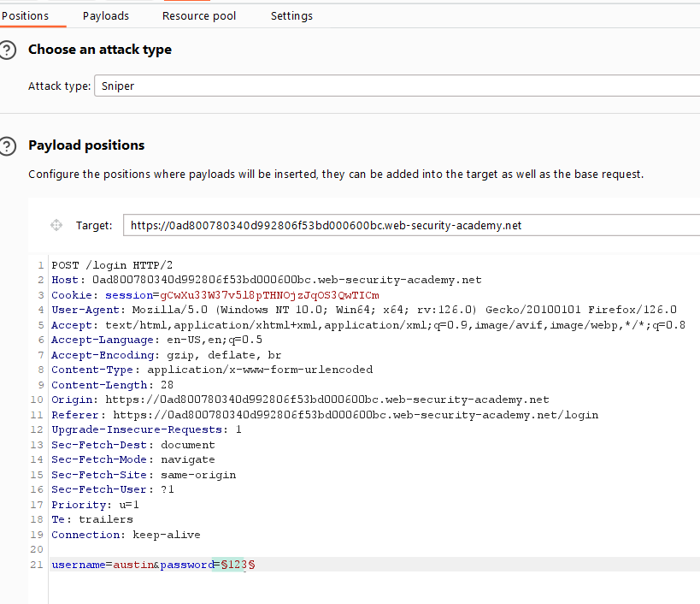

Add wordlist

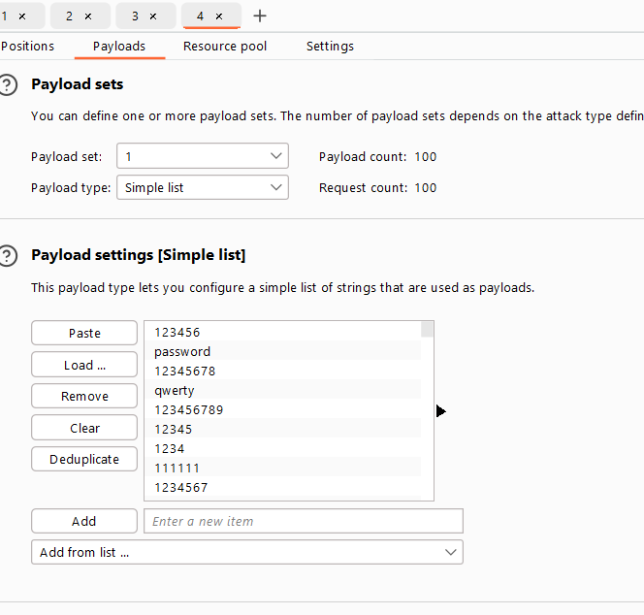

Start attack

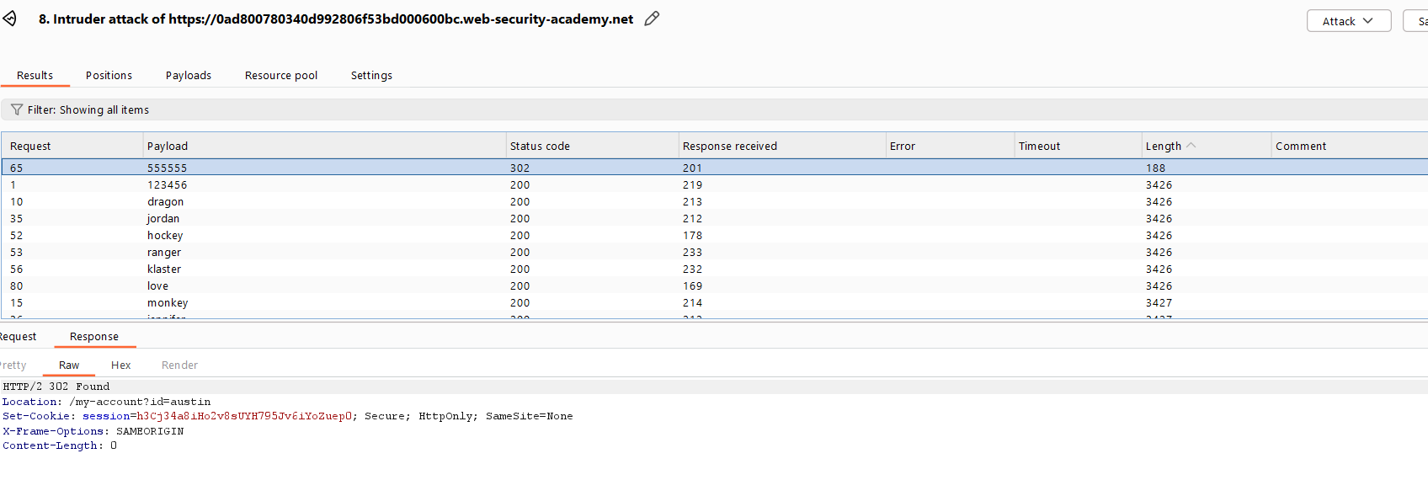

Let login I just login manually

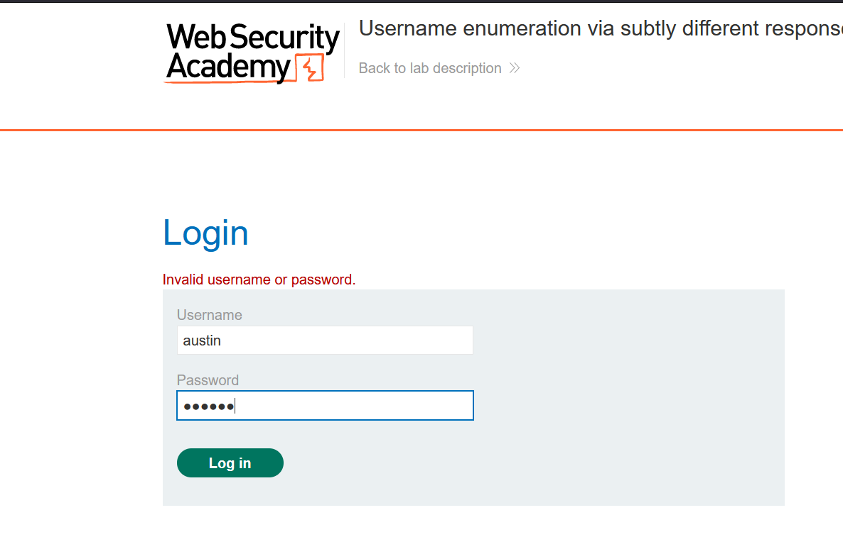

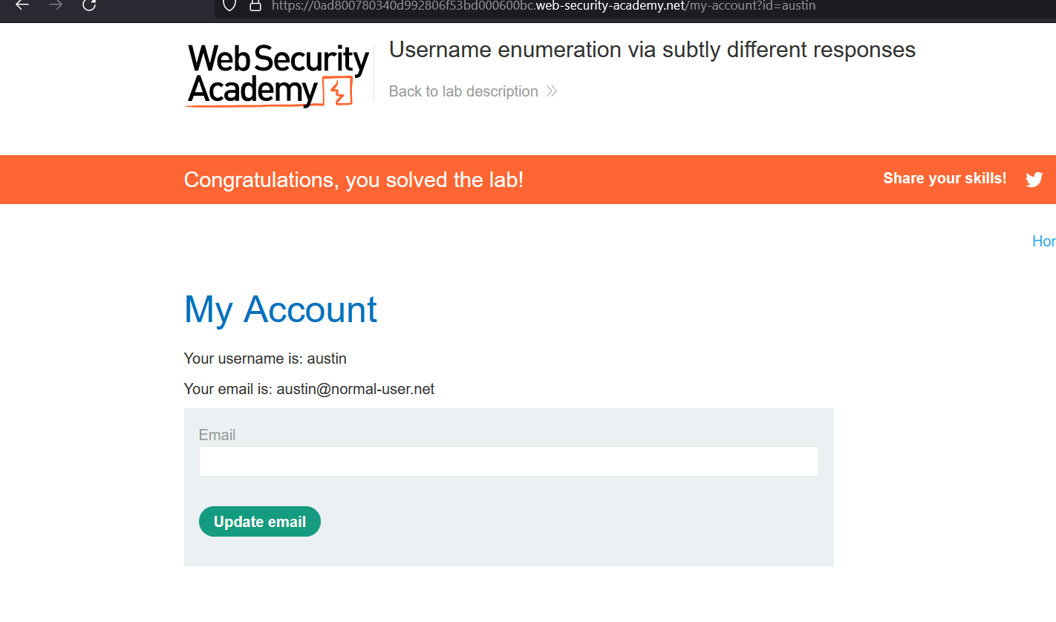

**Done**

# Methods: 1. Lab: 3. Username enumeration via response timing

[**https://portswigger.net/web-security/authentication/password-based/lab-username-enumeration-via-response-timing**](https://portswigger.net/web-security/authentication/password-based/lab-username-enumeration-via-response-timing)

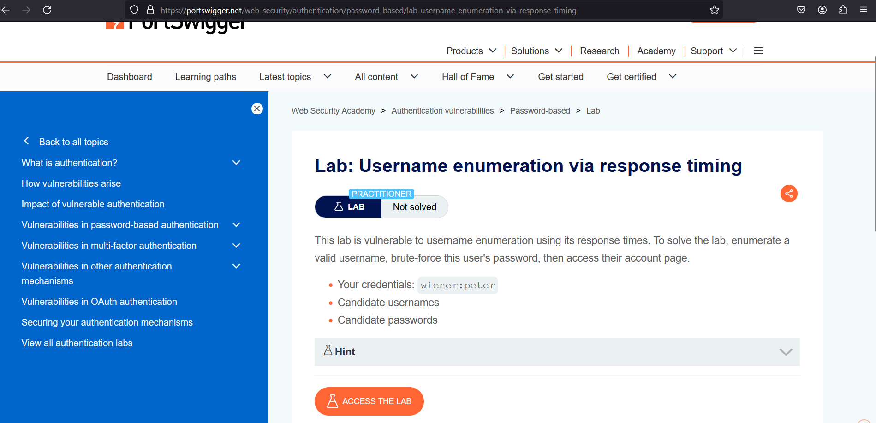

**In This Lab scenario the login page has IP-based brute-force protection:**

**Let Access the Lab**

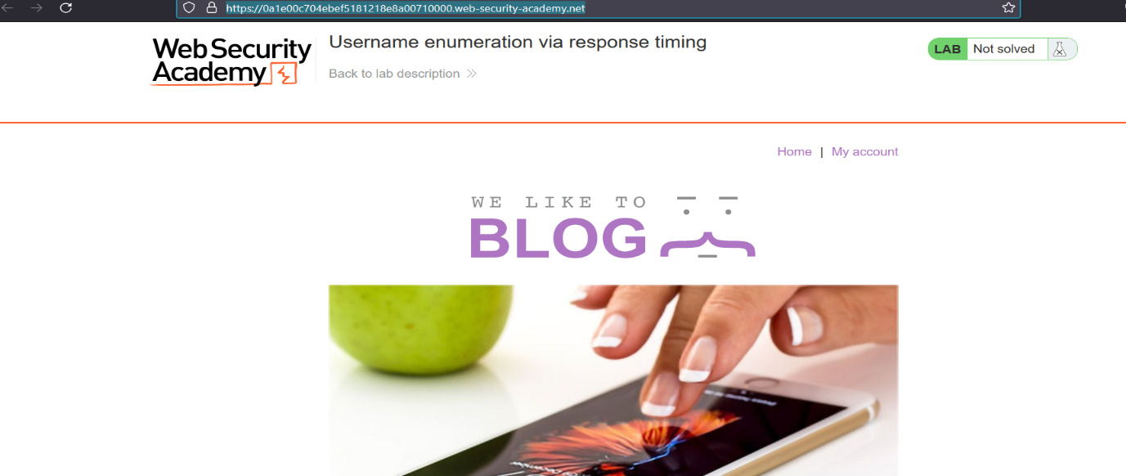

Go To My account

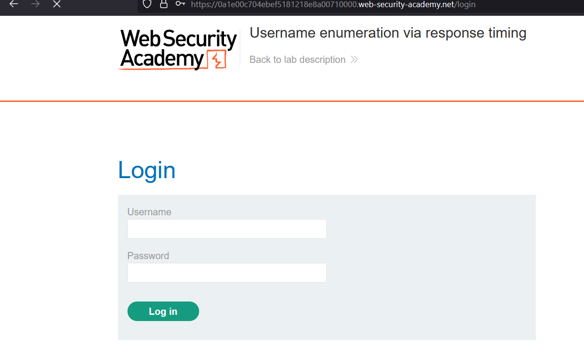

Let try manually guess and let see after how many attempts he block us:

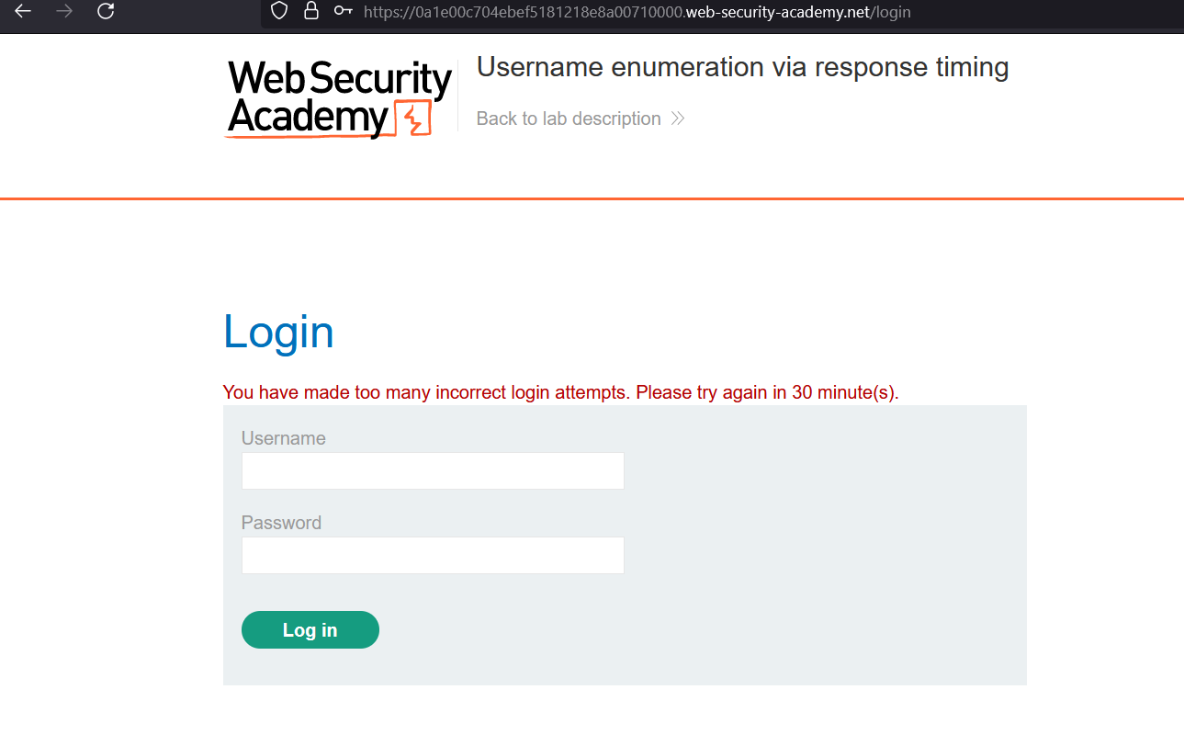

I got block 2 or 3 attempts

To Get More Log-in Attempts We need to use Headers

We Going to User “**X-FORWARDED-FOR”** Header

**What X-Forwarded-for header do, basically it tells the webserver the request of clint came for which particular Ip.**

**X-Forwarded-For header allows Us to spoof Our IP address and bypass the IP-based brute-force protection**.

Let try:

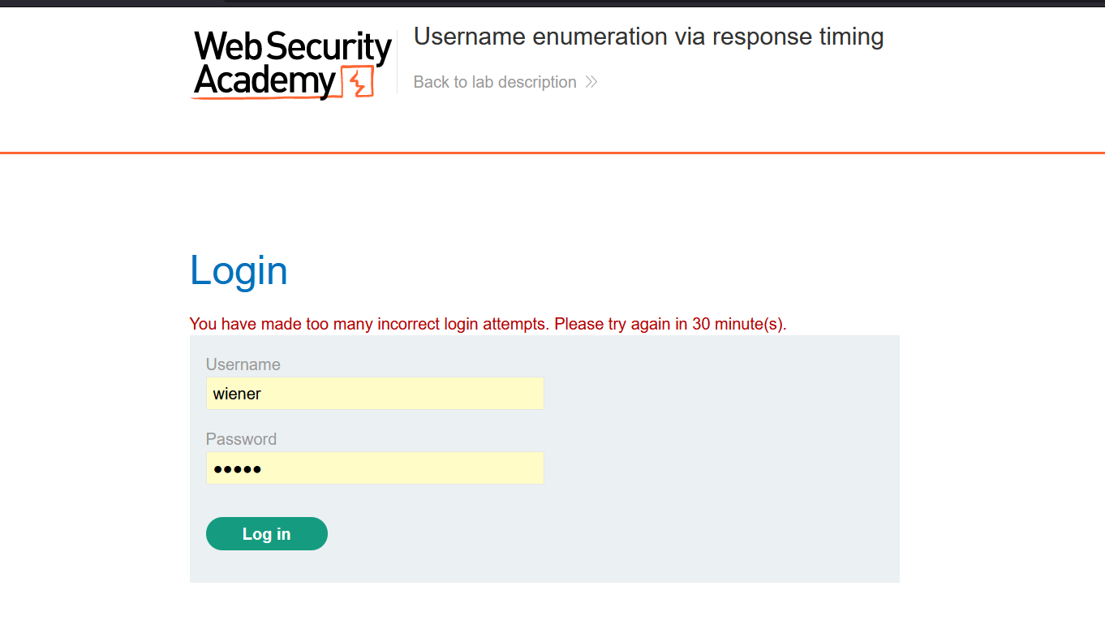

Capture the request

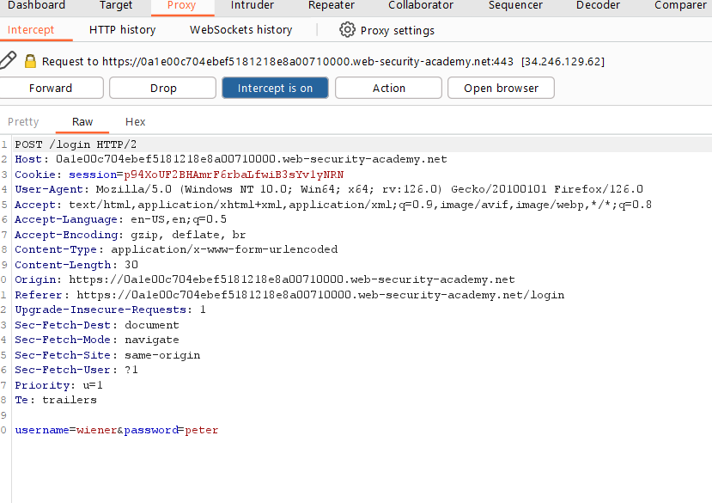

Send this to Repeater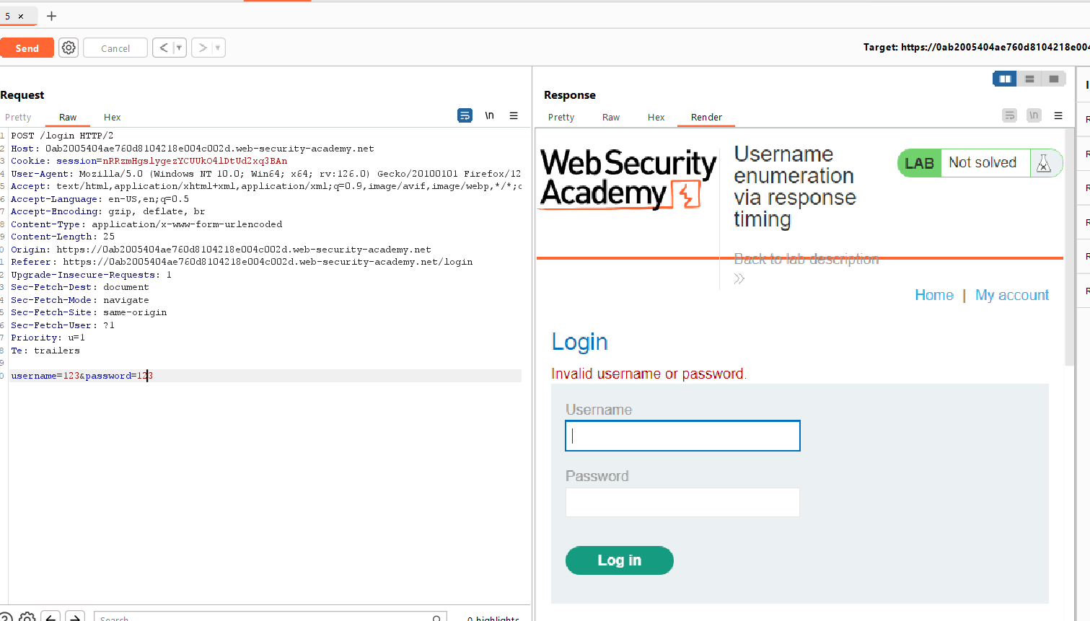

This is 1st Wrong attempt

After 3rd attempt my IP got blocked

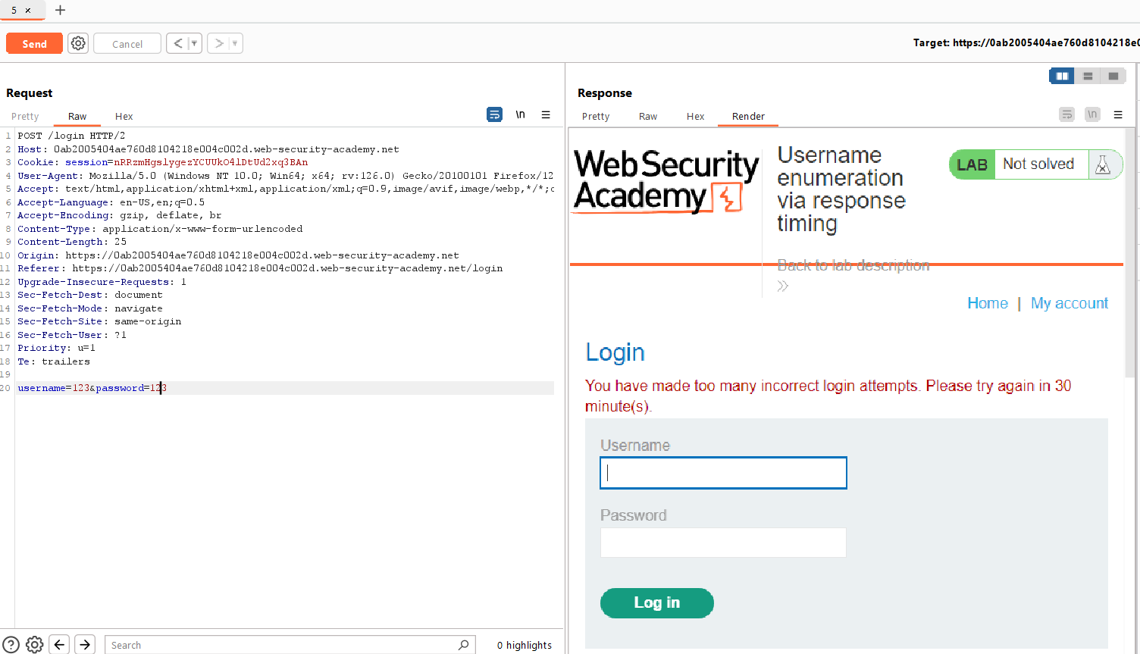

Let Add X-Forwarded-For header to this request

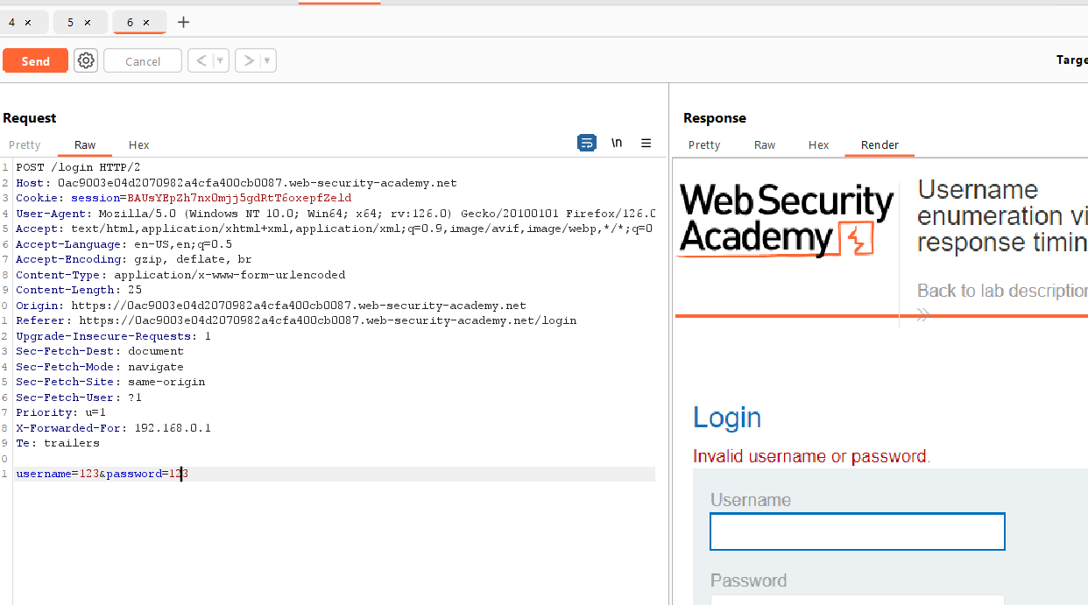

I didn’t Get Block This time after adding “X-Forwarded-For”

**Use Ip in X-forwarded-for**

1. But wait there I another fault that called response time

If we enter a valid wrong username and wrong password

There is delay in response time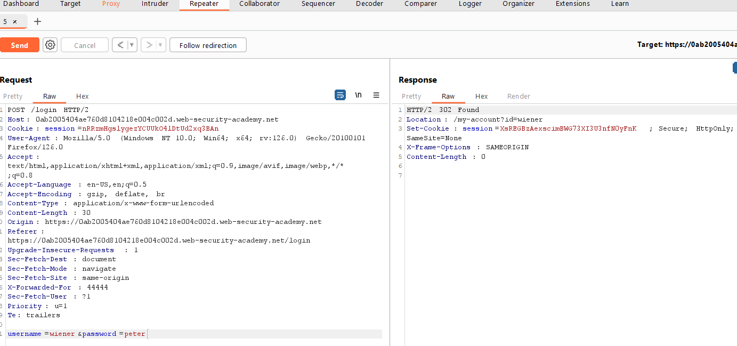

**So, this is my valid user credential**

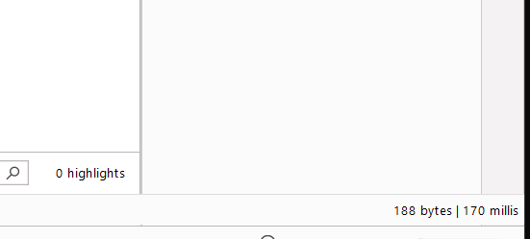

**And it took 170 milli sec to response**

**But when I add more character to password to make my password long the server got load**

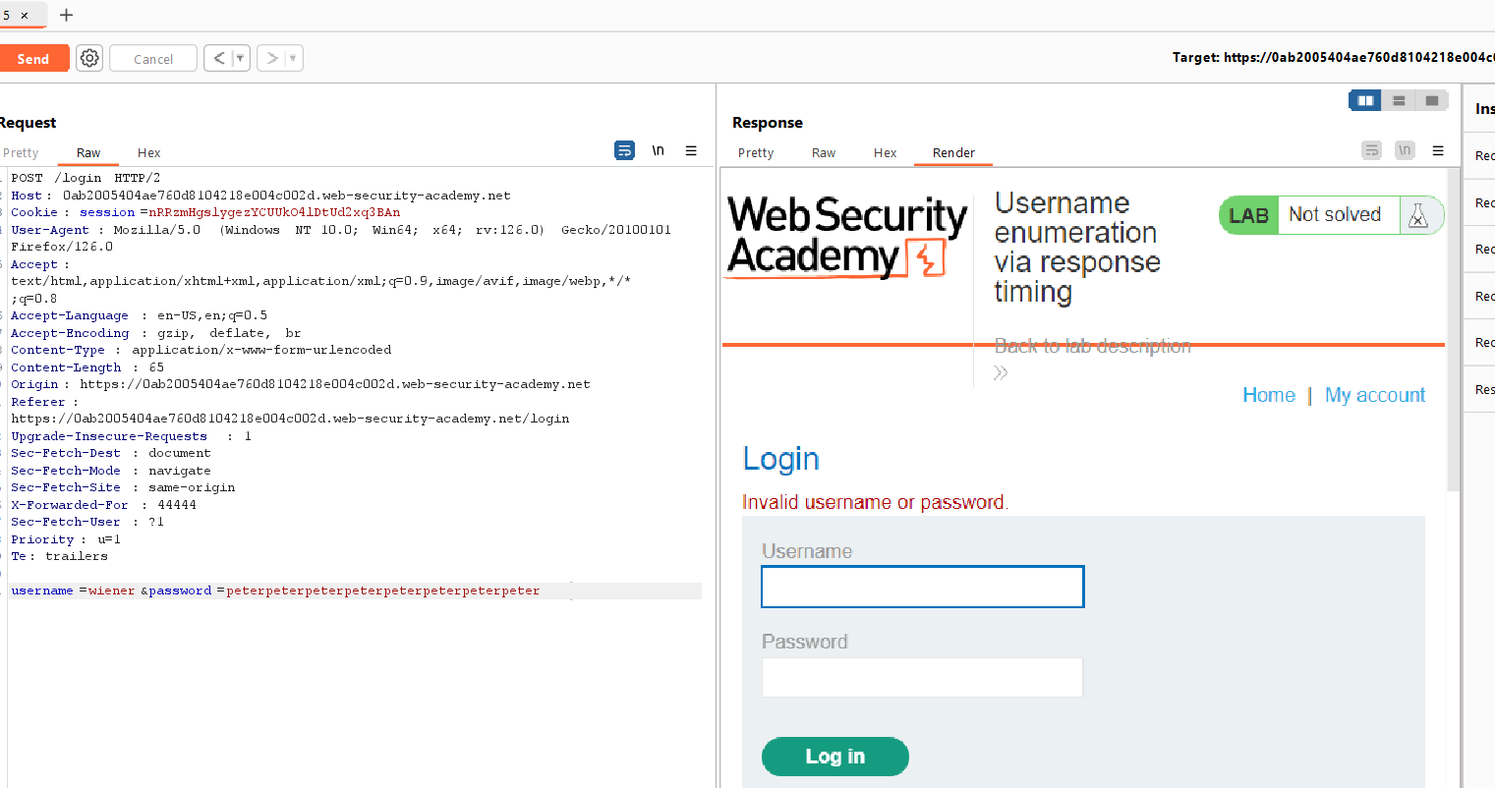

**When I add more, I got delay in response last one is 170 mili sec and this is 359 milli sec,**

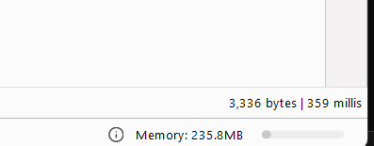

**That mean more longer password string and valid user name more the delay in response**

**Let brute it:**

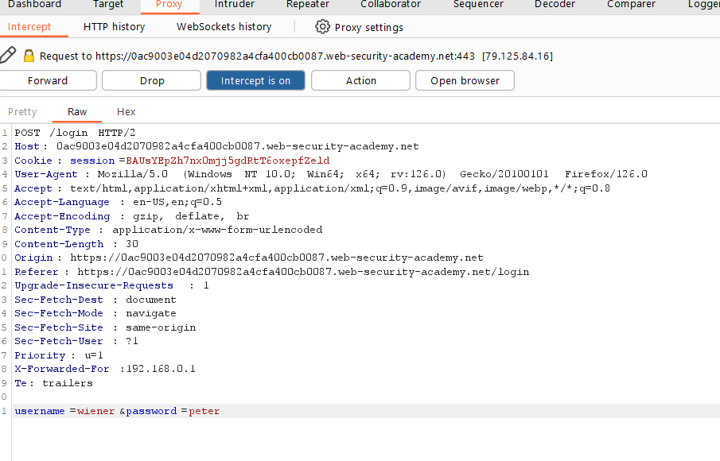

**So let send this request to Intruder and add the header and longer password**

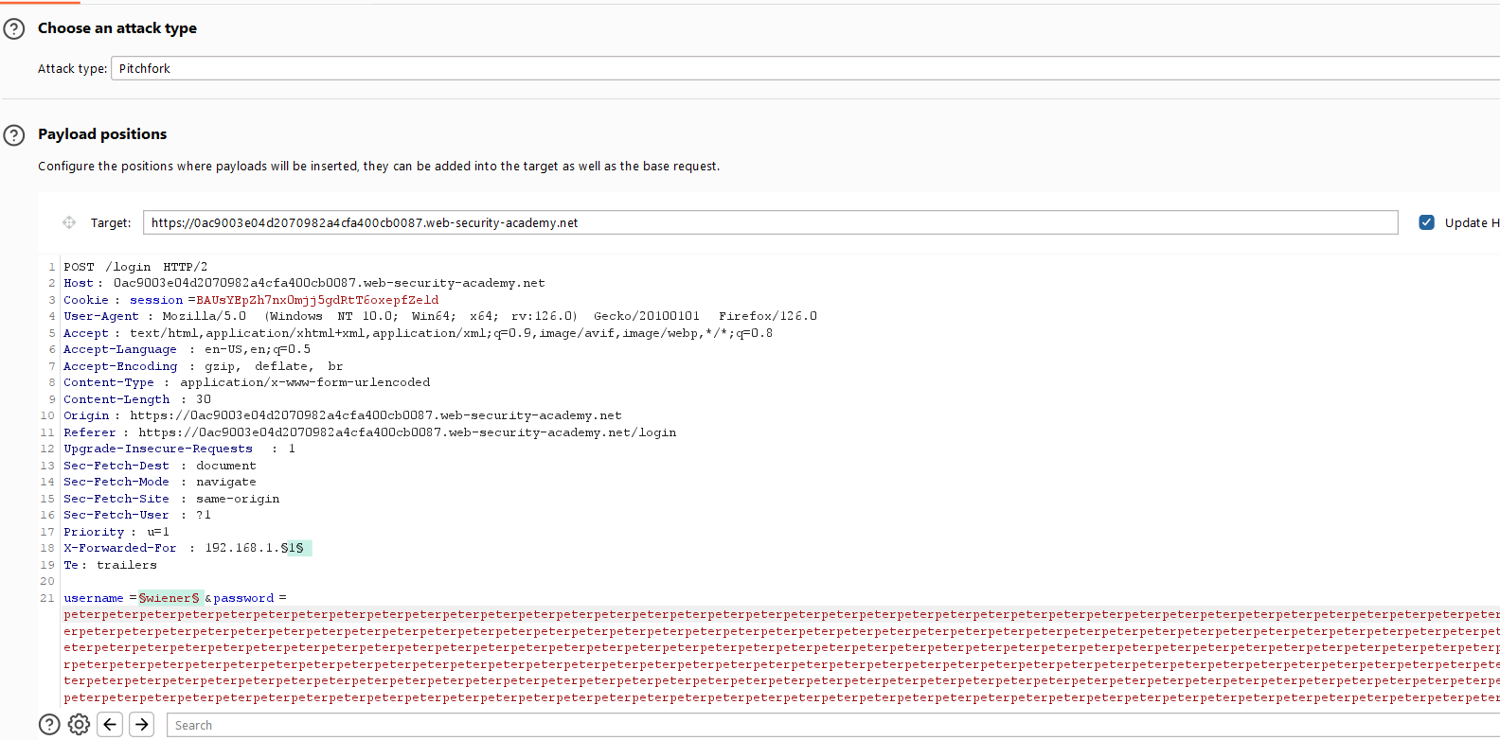

**Add payload positions**

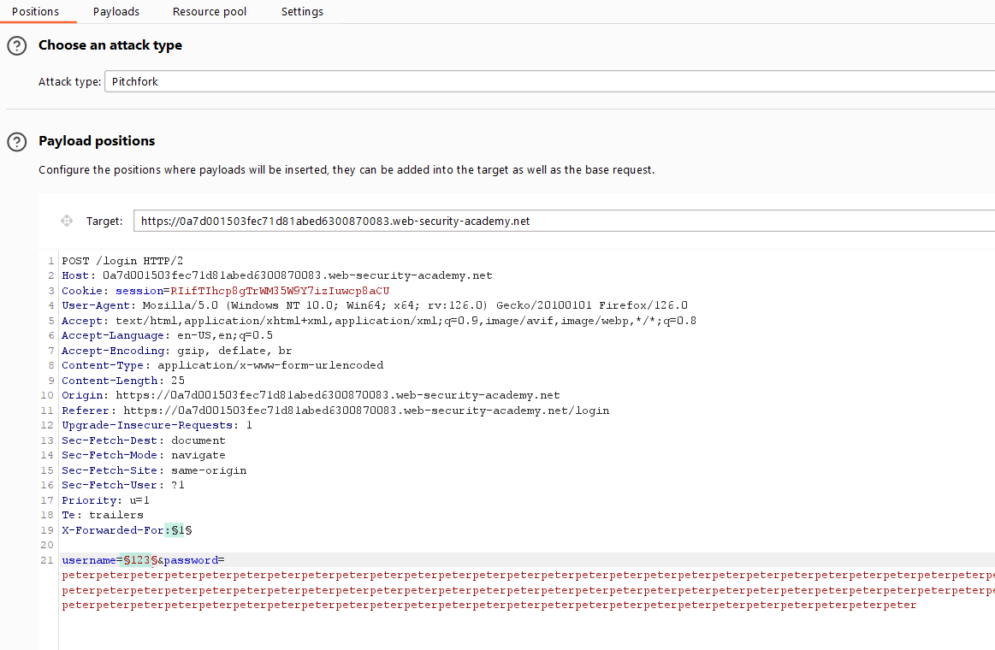

**Use Pitchfork rather than sniper bez use 2 wordlist and brute-force together**

**But we have another that called cluster bomb that is very usefull**

**It take word of 1st wordlist and try 2nd wordlist in 1st word and mover continue**

**Let use pitchfork for now**

**Now set 1st payload** 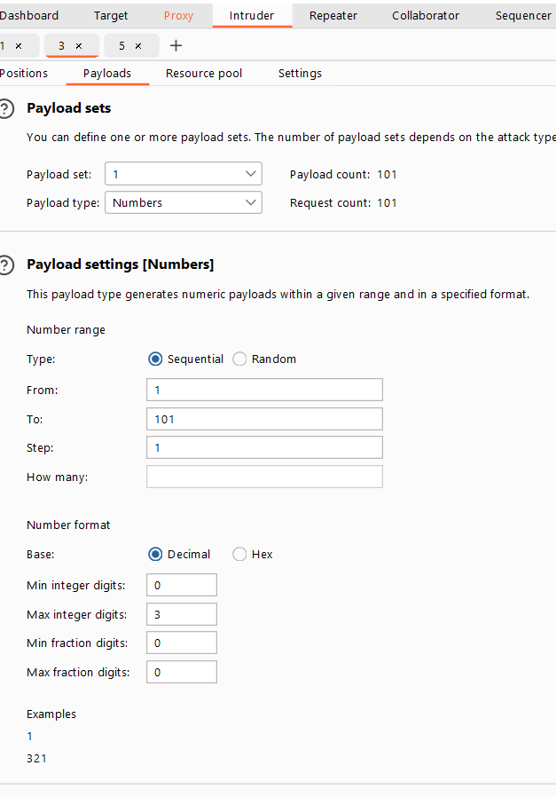

* On the **Payloads** tab, select payload set 1.
* Select the **Numbers** payload type.
* Enter the range 1 – 101 bez we have total of 101 password in wordlist.
* set the step to 1.
* Set the max fraction digits to 0.

This will be used to spoof your IP.

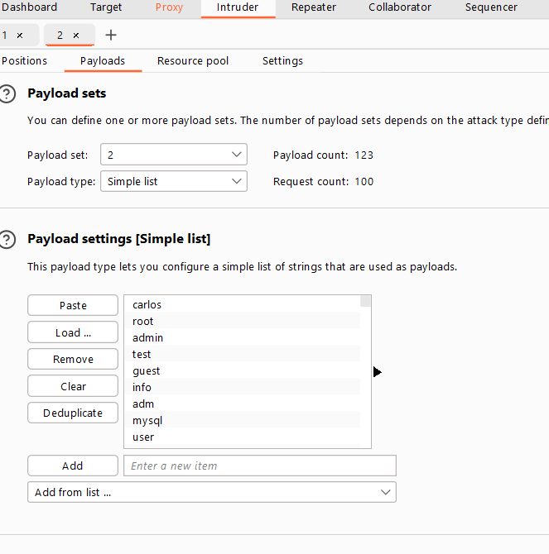

**In payload set 2 past wordlists**

**Start Attacks** 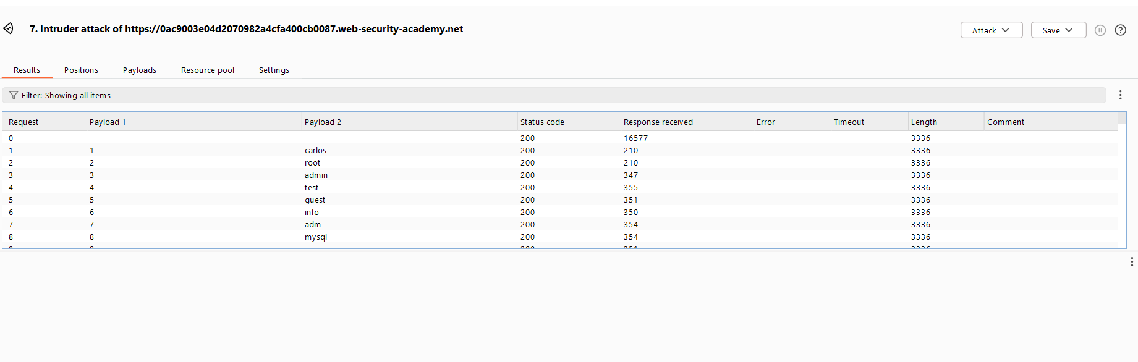

**Go to 3 dot**

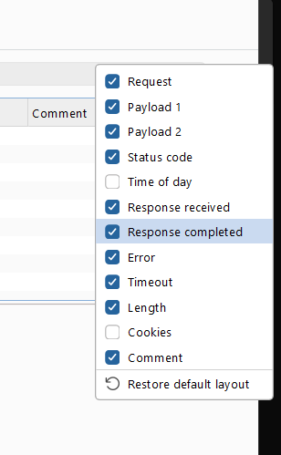

**Enable these 2 options**

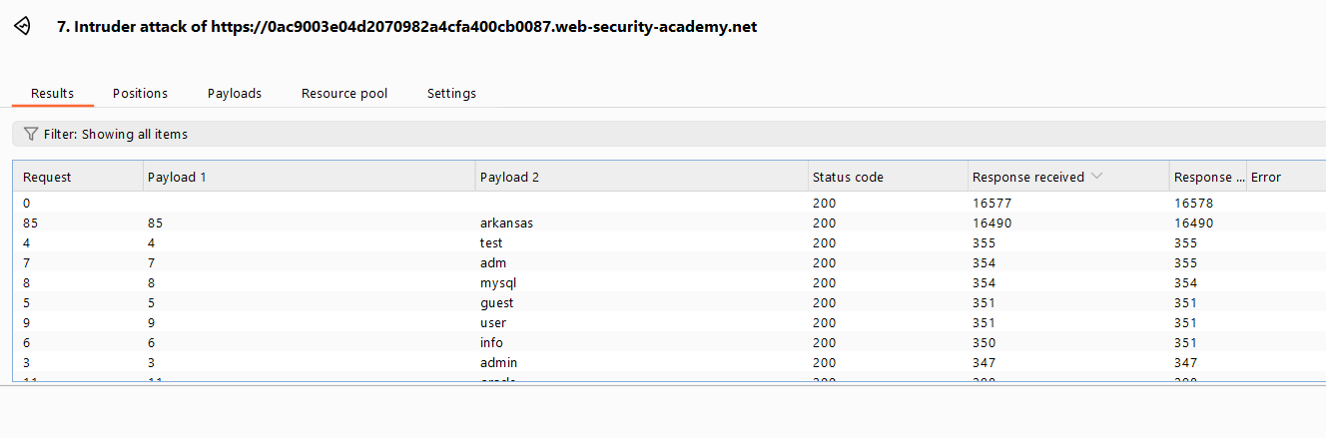

**Here we can see this “Arkansas” took over 16 sec. Mean this correct username**

**Now let find password.**

**Everything is same just past password wordlist in 2nd payload set.**

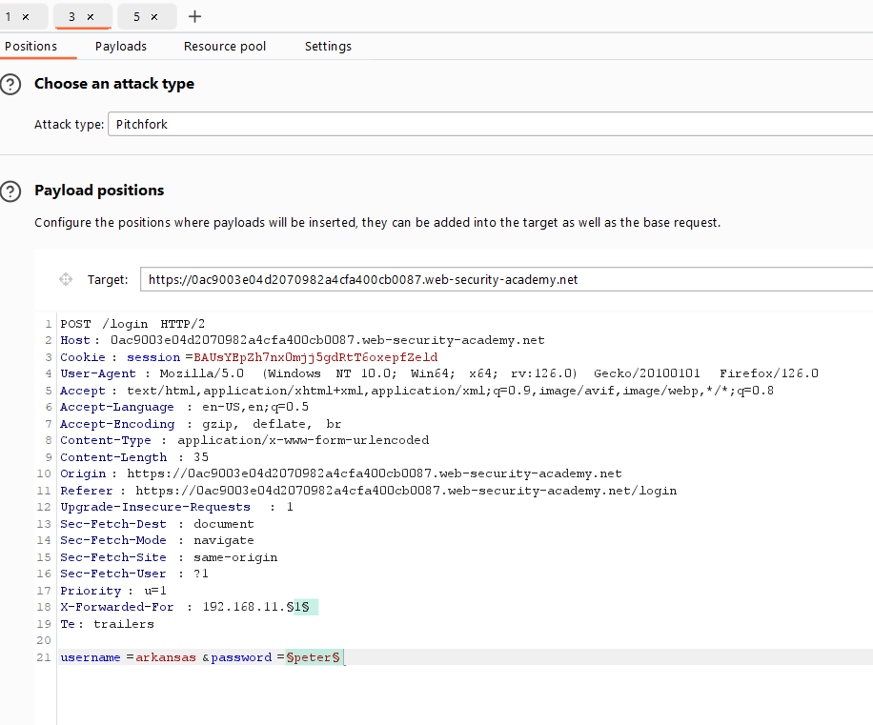

**Let set payload**

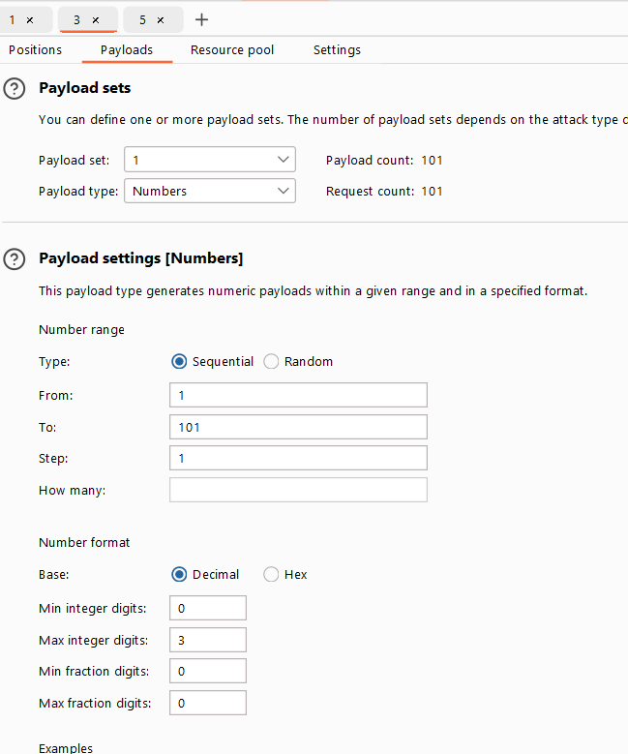

**And for payload set 2**

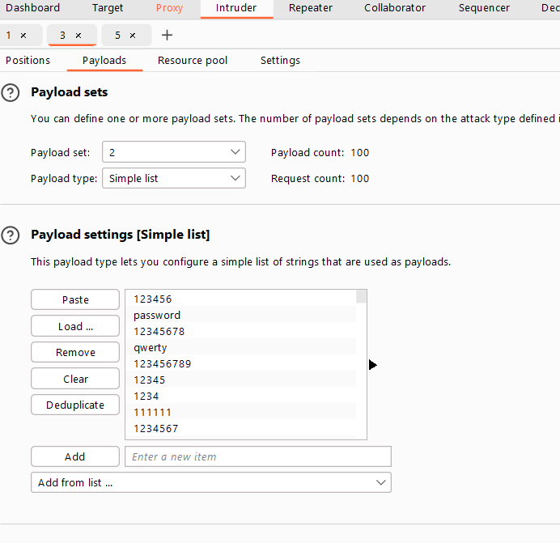

**Start Attack**

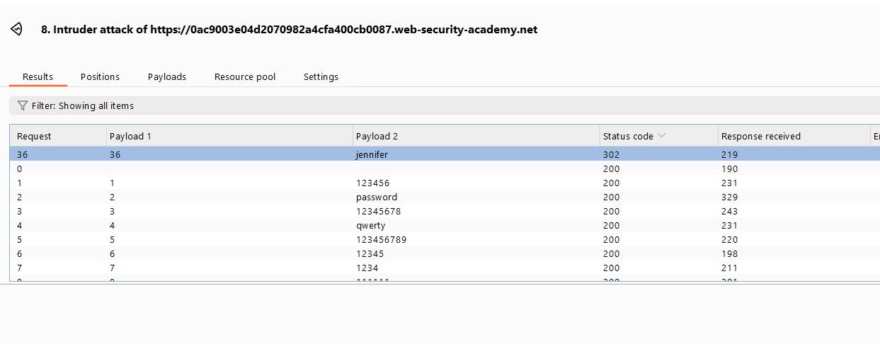

**Here is Jennifer with 302 mean a valid password.**

**Send this To repeater to verify**

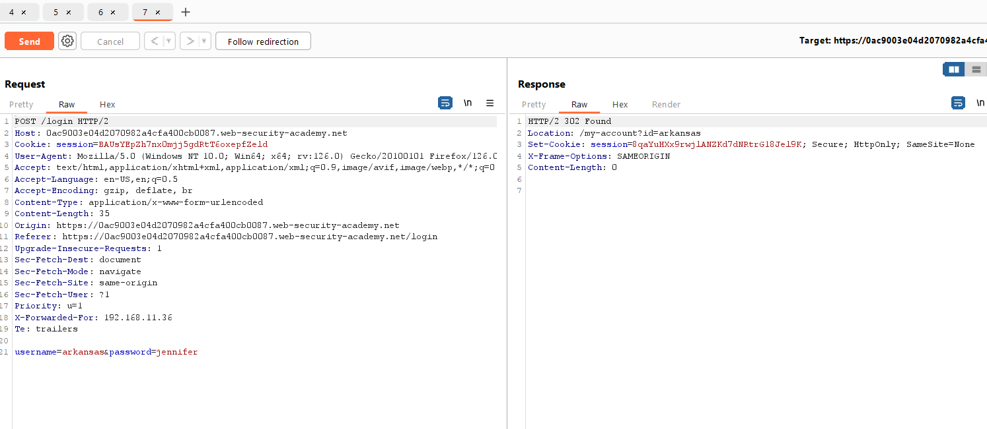

**Let send this**

**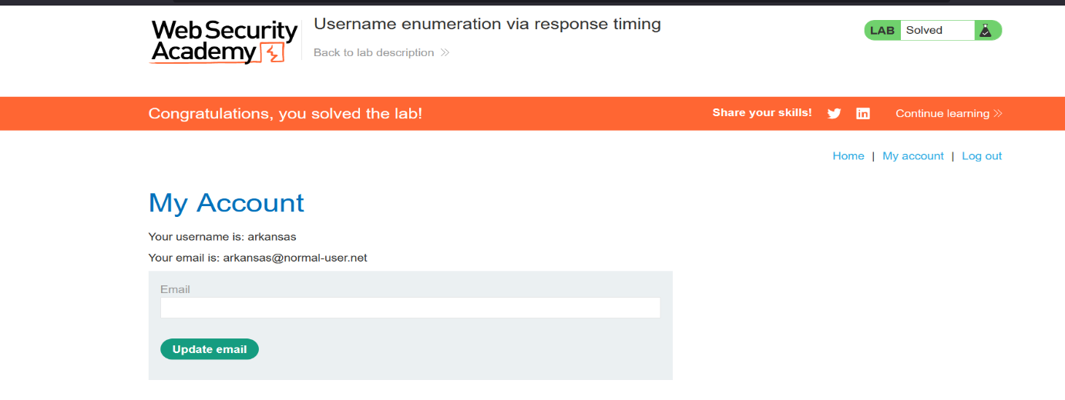  
Done**

# Method: 2. Flawed brute-force protection

It is highly likely that a brute-force attack will involve many failed guesses before the attacker successfully compromises an account.

Logically, brute-force protection revolves around trying to make it as tricky as possible to automate the process and slow down the rate at which an attacker can attempt logins.

The two most common ways of preventing brute-force attacks are:

* Locking the account that the remote user is trying to access if they make too many failed login attempts
* Blocking the remote user's IP address if they make too many logins attempts in quick succession

Both approaches offer varying degrees of protection, but neither is invulnerable, especially if implemented using flawed logic.

For example, you might sometimes find that your IP is blocked if you fail to log in too many times. In some implementations, the counter for the number of failed attempts resets if the IP owner logs in successfully

This means an attacker would simply have to log in to their own account every few attempts to prevent this limit from ever being reached.

In this case, merely including your own login credentials at regular intervals throughout the wordlist is enough to render this Défense virtually useless.

# Methods: 2. Lab: 4. Broken brute-force protection, IP block

[**https://portswigger.net/web-security/authentication/password-based/lab-broken-bruteforce-protection-ip-block**](https://portswigger.net/web-security/authentication/password-based/lab-broken-bruteforce-protection-ip-block)

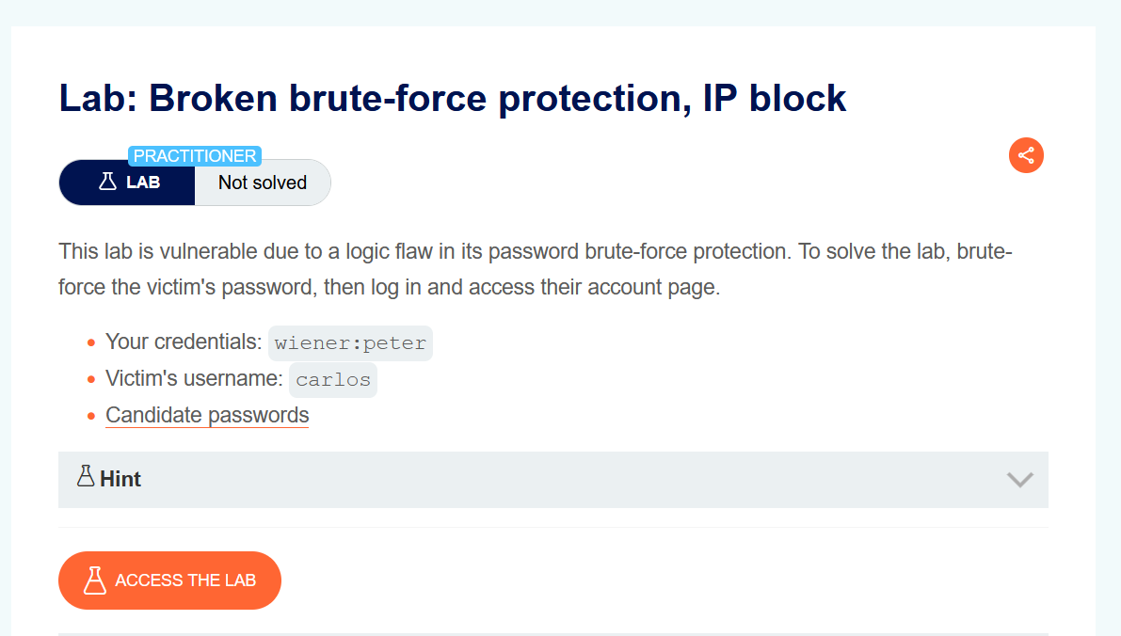

**In This Lab scenario**

We have our own credential as **wiener : peter** and **carlos** is another user and wordlist for password is given . If we observe closely our IP is temporarily blocked for 1 min if we submit 3 incorrect logins in a row.

**Let Access The lab**

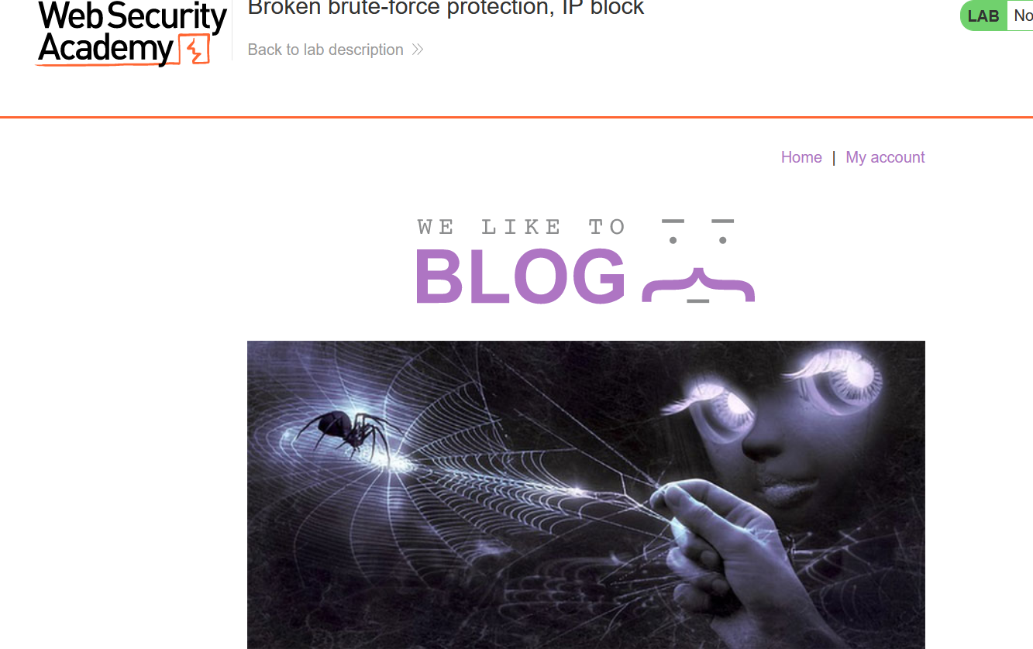

**Go to My account**

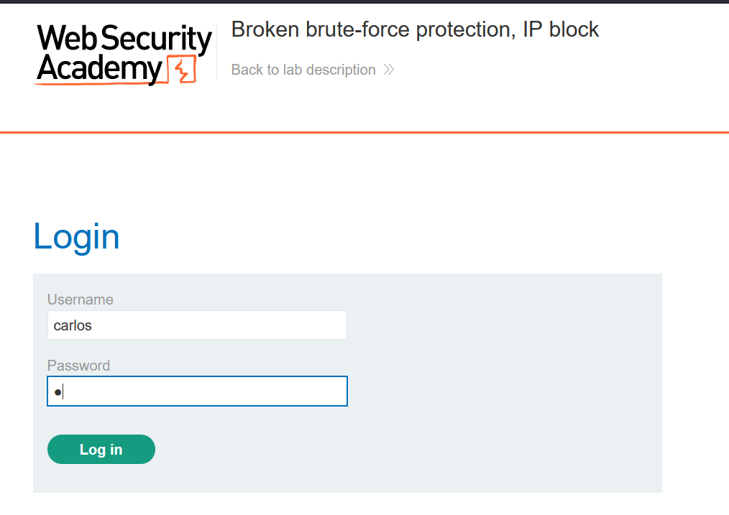

**Capture this Request**

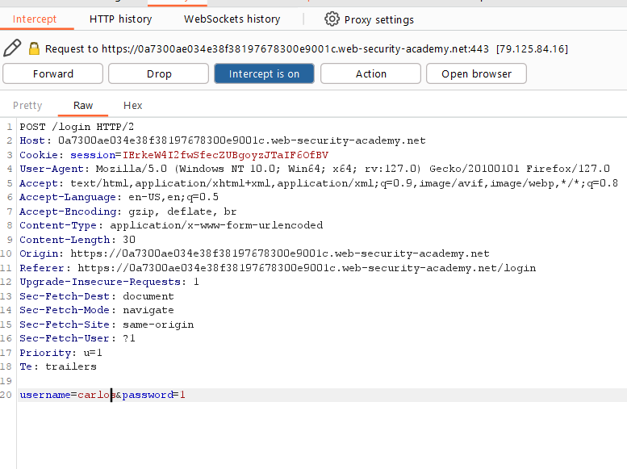

**Let Send this to Repeater to see what happened**

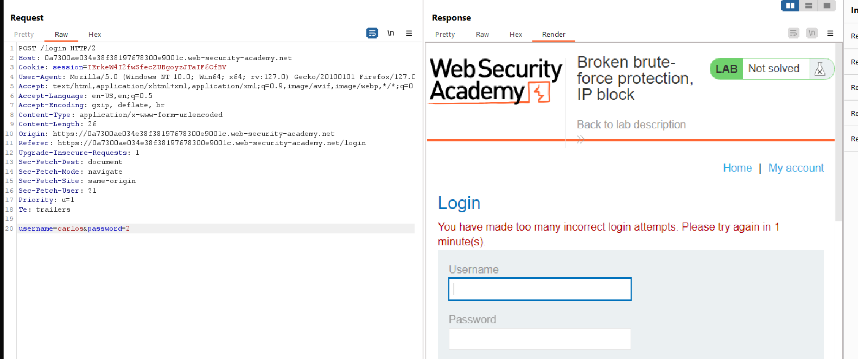

After 3 failed attempt I got blocked

There is another vulnerability

If I give username that is Incorrect it tells me that username is incorrect and not exist in database

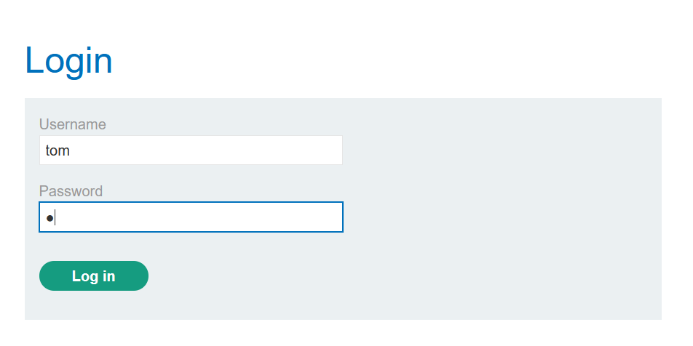

It shows username is incorrect

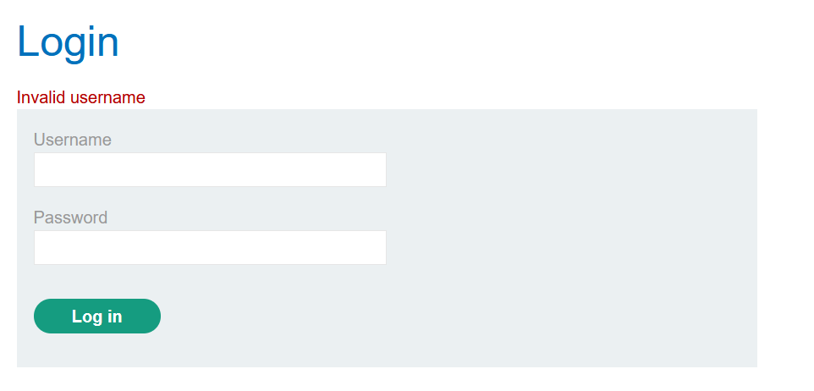

In that case an attacker can easily verify that the Username he is using is exist or not.

Now let use Carlos as username and make a failed attempt to log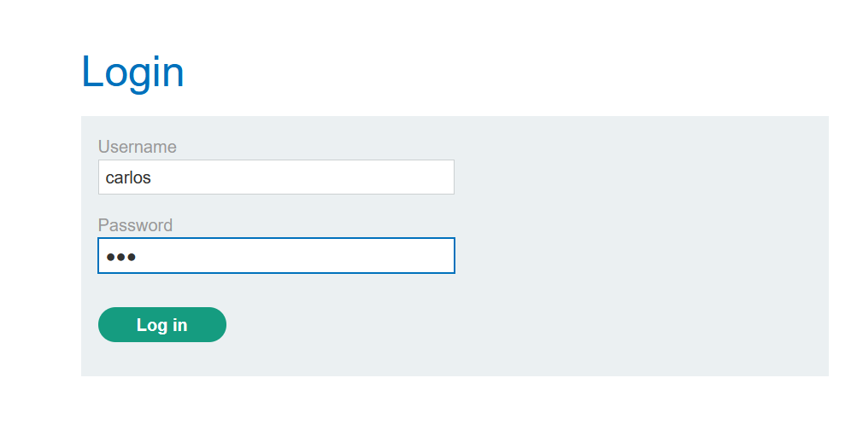

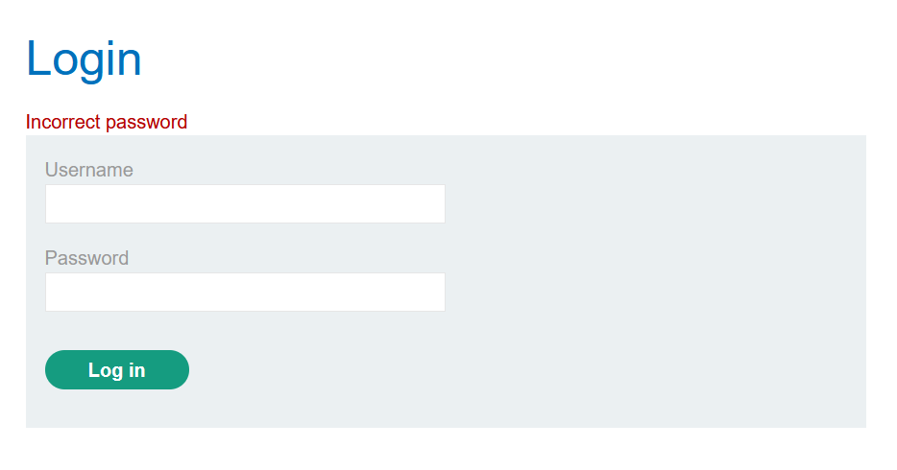

So, we can verify that Carlos is exist:

**Let Login again**

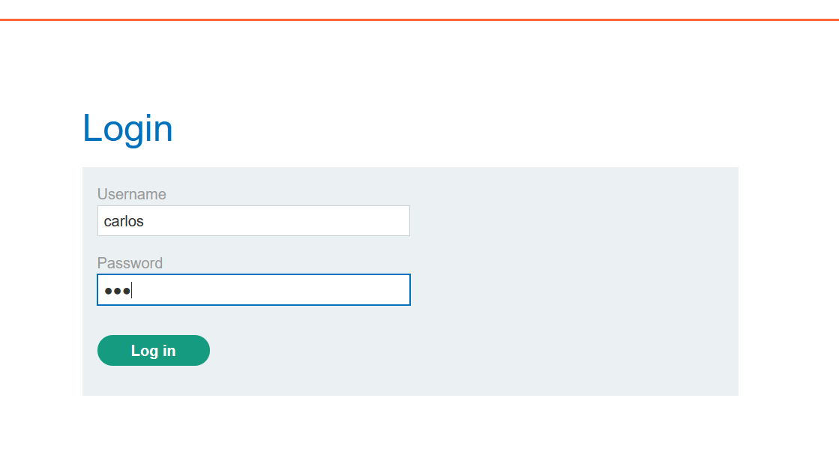

**Capture the Request**

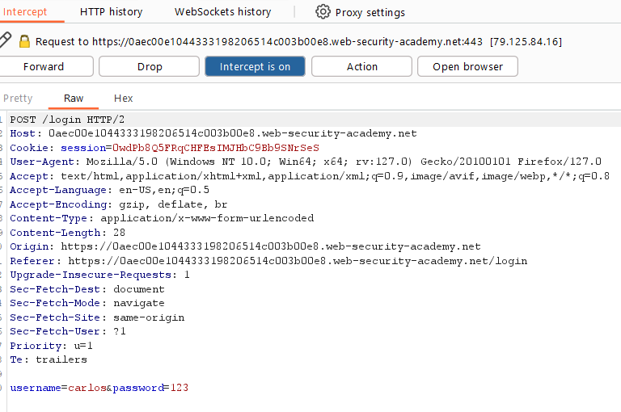

Send To Intruder

What we need to do, basically if I try two fail logins attempt as Carlos and the 3rd as Wiener. We can bypass this Ip block restriction.

We need to create a Username wordlist with this kind of format:

* + 1. Wiener
    2. Carlos
    3. Carlos
    4. Wiener

And same goes to password wordlist:

* Our password: peter
* Brute forcing password
* Brute forcing password
* Our password: peter

So let create for Username I’m creating python program

print("Username list")

for i in range (150):

    if i % 3:

        print("carlos")

    else:

        print("wiener")

For Password list we need to add manually

peter

123456

password

peter

12345678

qwerty

peter

123456789

12345

peter

1234

111111

peter

1234567

dragon

peter

123123

baseball

peter

abc123

football

peter

monkey

letmein

peter

shadow

master

peter

666666

qwertyuiop

peter

123321

mustang

peter

1234567890

michael

peter

654321

superman

peter

1qaz2wsx

7777777

peter

121212

000000

peter

qazwsx

123qwe

peter

killer

trustno1

peter

jordan

jennifer

peter

zxcvbnm

asdfgh

peter

hunter

buster

peter

soccer

harley

peter

batman

andrew

peter

tigger

sunshine

peter

iloveyou

2000

peter

charlie

robert

peter

thomas

hockey

peter

ranger

daniel

peter

starwars

klaster

peter

112233

george

peter

computer

michelle

peter

jessica

pepper

peter

1111

zxcvbn

peter

555555

11111111

peter

131313

freedom

peter

777777

pass

peter

maggie

159753

peter

aaaaaa

ginger

peter

princess

joshua

peter

cheese

amanda

peter

summer

love

peter

ashley

nicole

peter

chelsea

biteme

peter

matthew

access

peter

yankees

987654321

peter

dallas

austin

peter

thunder

taylor

peter

matrix

mobilemail

peter

mom

monitor

peter

monitoring

montana

peter

moon

Moscow

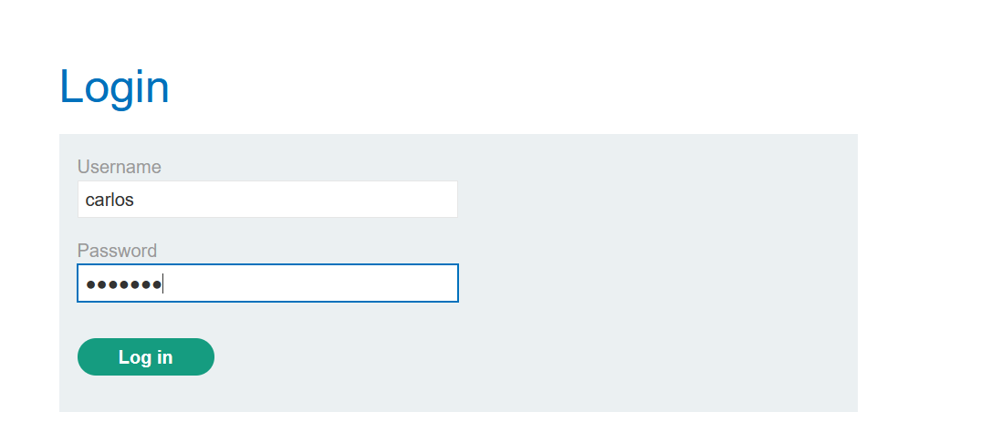

I try to make this minimum so it takes less pages and easy to copy and paste, so total words in both are 150

Let add payload position:

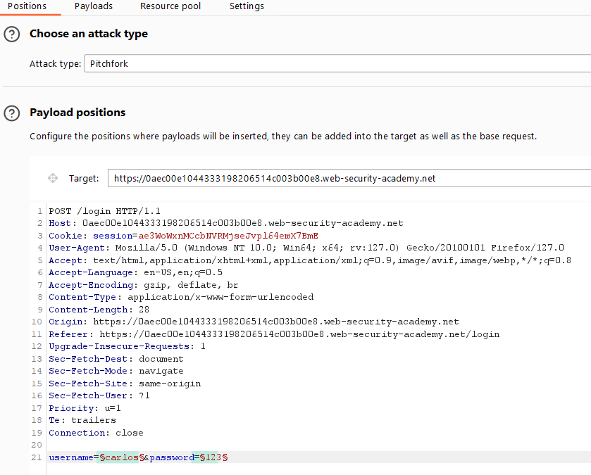

We are using pitchfork bez it uses 1st word of 1st wordlist and 1st word of 2nd wordlist.

In 1st payload position add username wordlist generated by python

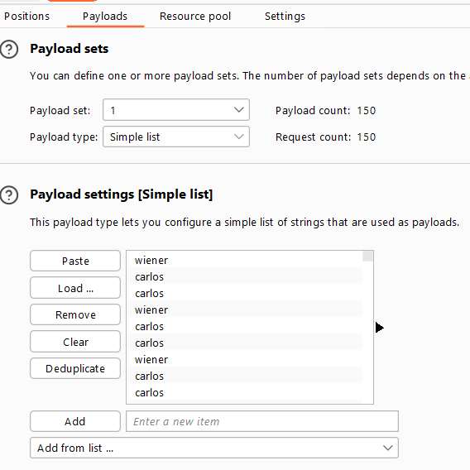

And In 2nd payload position add use above wordlist

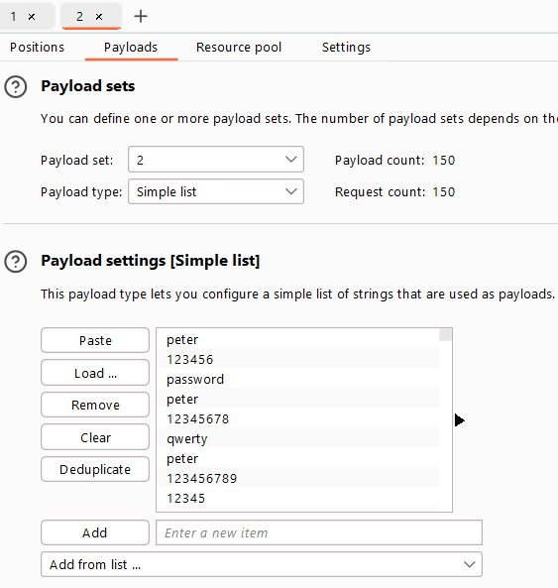

Before starting we need to change one more thing

Go to this Resource pool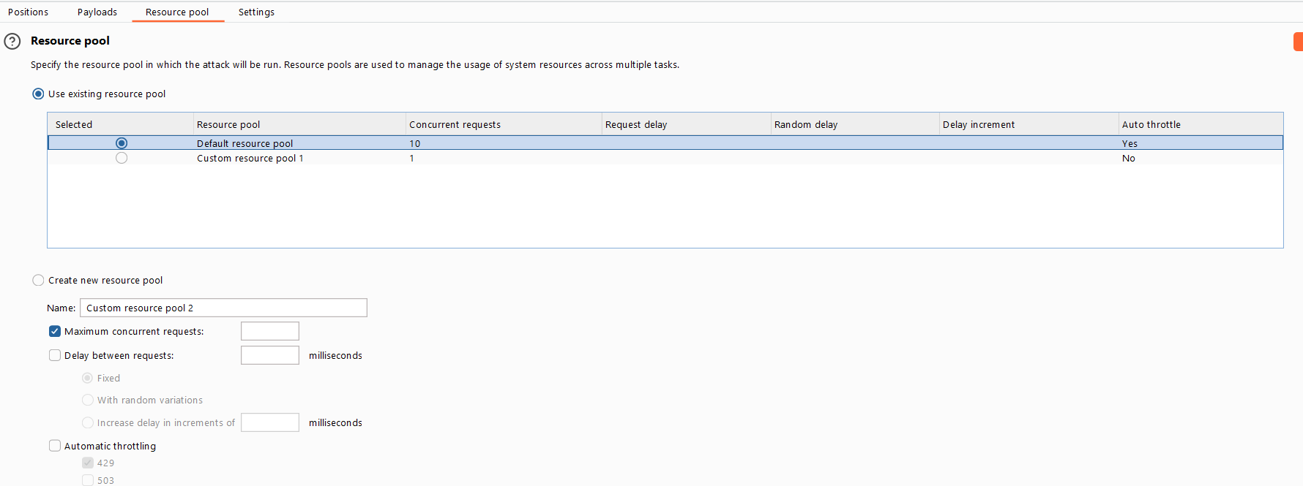

I already created 1 what kind of work it will do. It works as thread.

By default, it sends 10 requests at time, and we need to send 1 request at once.

So, tap on create:

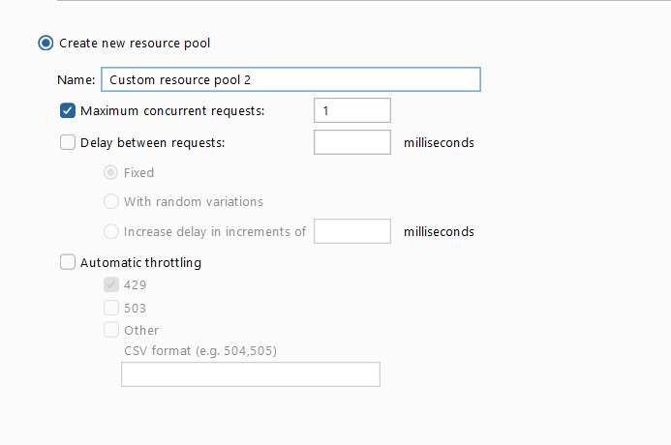

Set maximum value to 1

Sometime it didn’t appear



So, start attack and cancel immediately

Then it showed up

Select and Attack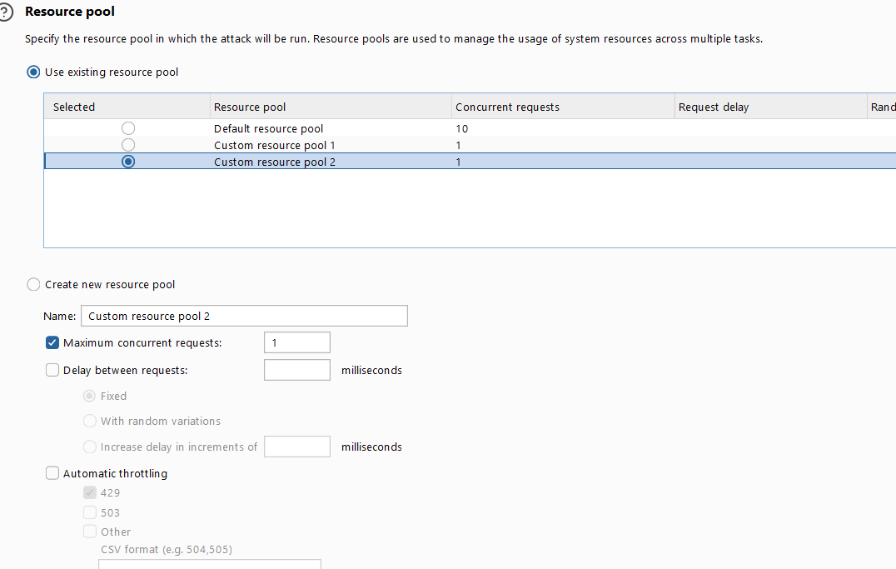

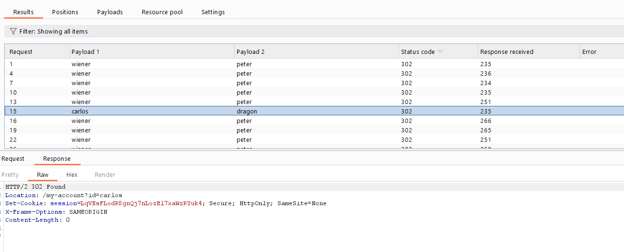

We got password let login



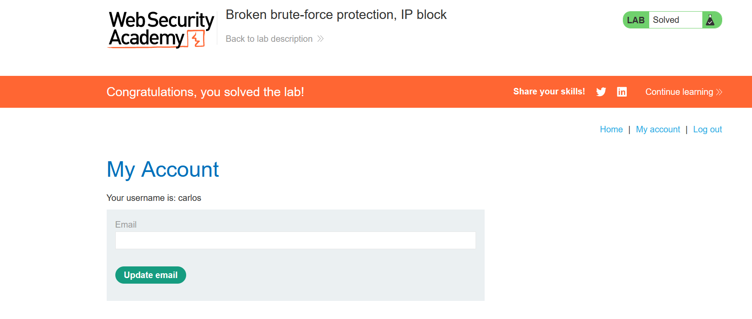

DONE

# Methods: 3. Account locking

One way in which websites try to prevent brute-forcing is to lock the account if certain suspicious criteria are met, usually a set number of failed login attempts. Just as with normal login errors, responses from the server indicating that an account is locked can also help an attacker to enumerate usernames.

Locking an account offers a certain amount of protection against targeted brute-forcing of a specific account. However, this approach fails to adequately prevent brute-force attacks in which the attacker is just trying to gain access to any random account they can.

For example, the following method can be used to work around this kind of protection:

1. Establish a list of candidate usernames that are likely to be valid. This could be through username enumeration or simply based on a list of common usernames.
2. Decide on a very small shortlist of passwords that you think at least one user is likely to have. Crucially, the number of passwords you select must not exceed the number of login attempts allowed. For example, if you have worked out that limit is 3 attempts, you need to pick a maximum of 3 password guesses.
3. Using a tool such as Burp Intruder, try each of the selected passwords with each of the candidate usernames. This way, you can attempt to brute-force every account without triggering the account lock. You only need a single user to use one of the three passwords in order to compromise an account.

Account locking also fails to protect against credential stuffing attacks. This involves using a massive dictionary of username:password pairs, composed of genuine login credentials stolen in data breaches. Credential stuffing relies on the fact that many people reuse the same username and password on multiple websites and, therefore, there is a chance that some of the compromised credentials in the dictionary are also valid on the target website. Account locking does not protect against credential stuffing because each username is only being attempted once. Credential stuffing is particularly dangerous because it can sometimes result in the attacker compromising many different accounts with just a single automated attack.

# Method: 3. Lab: 5. Username enumeration via account lock

[**https://portswigger.net/web-security/authentication/password-based/lab-username-enumeration-via-account-lock**](https://portswigger.net/web-security/authentication/password-based/lab-username-enumeration-via-account-lock)

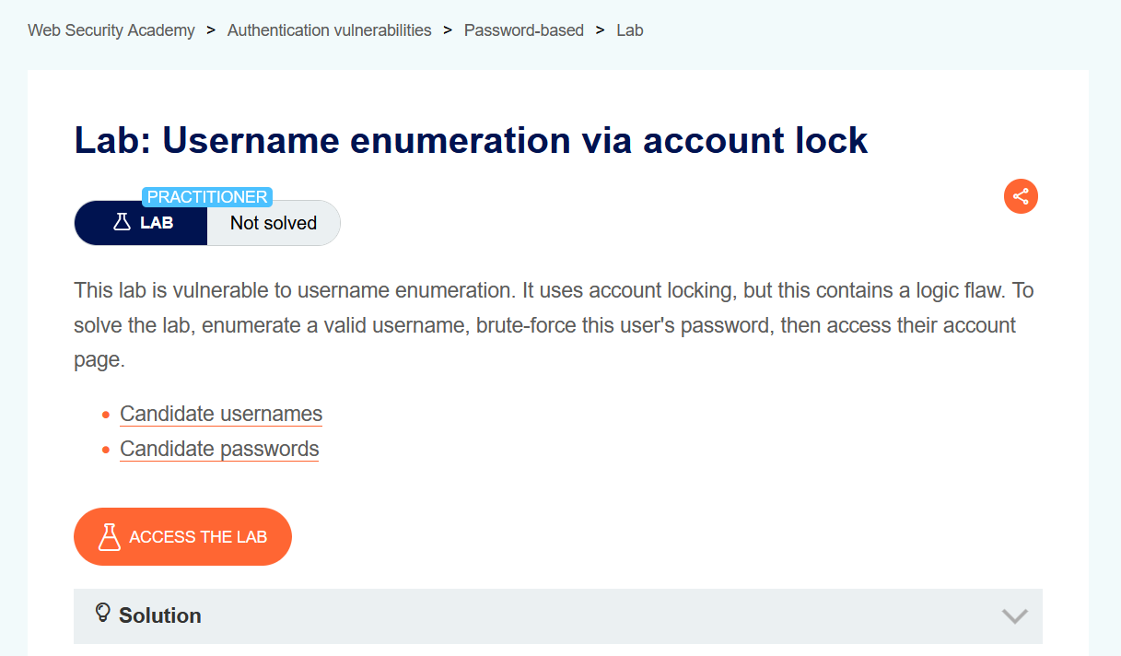

**In this lab scenario** If we try to brute force the User & pass the account of user will be locked and we get a different response.

**Let access the lab**

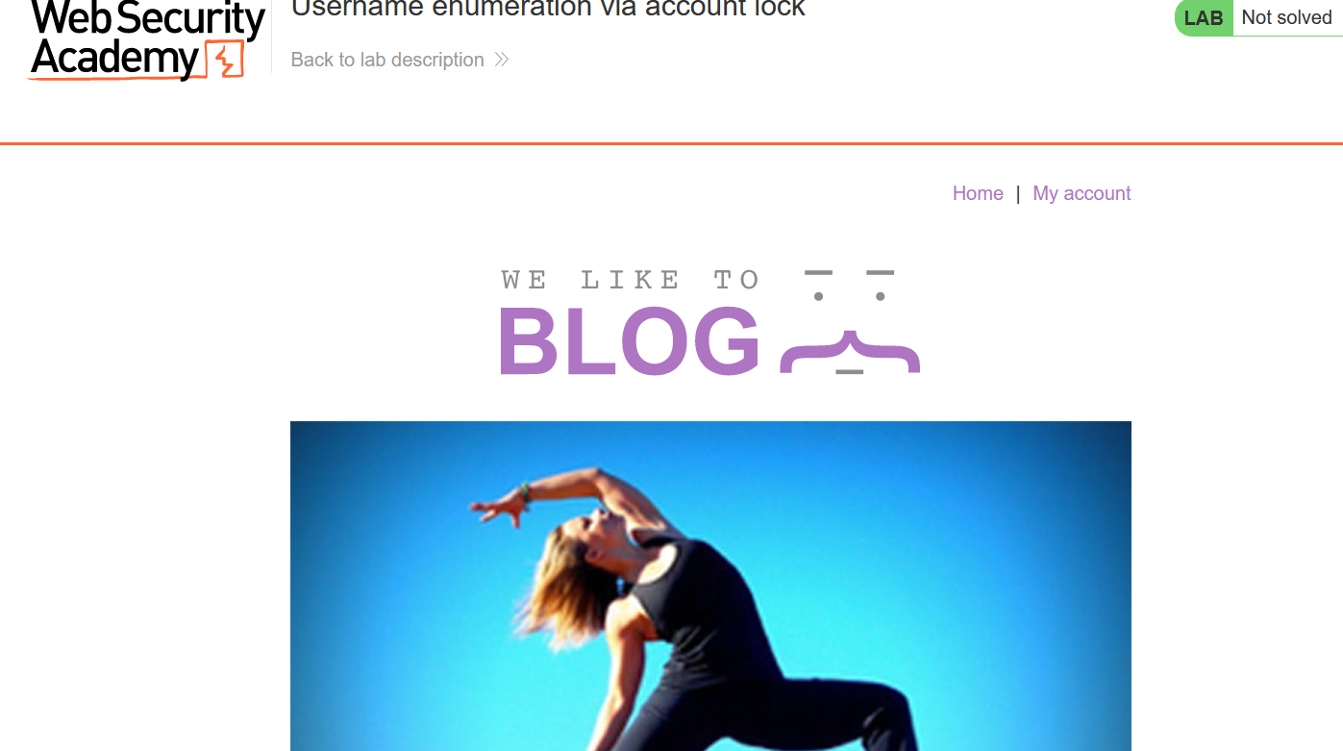

Go to my account

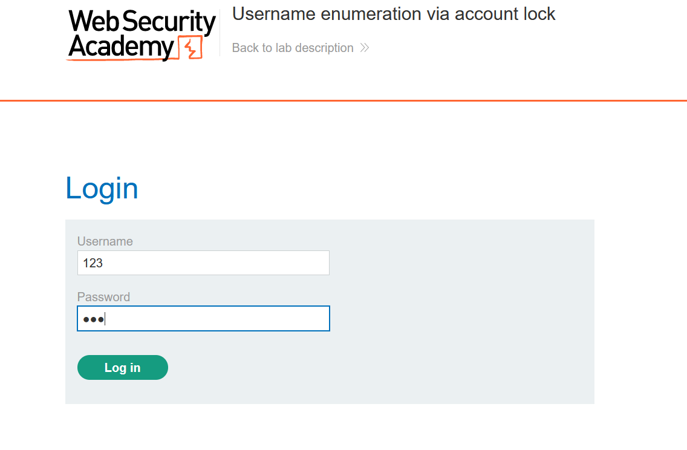

Capture the request

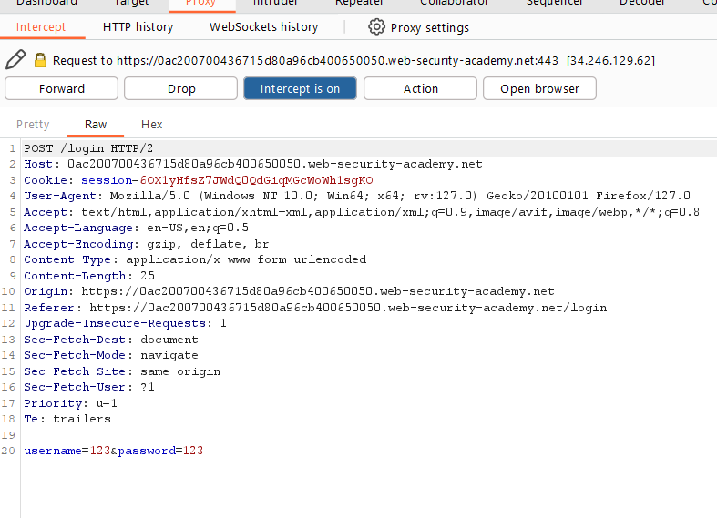

Send this to Intruder, we need to identify which account goanna lock

In order to we need to send 3 or more login request to a particular Username

So let mark the payload position

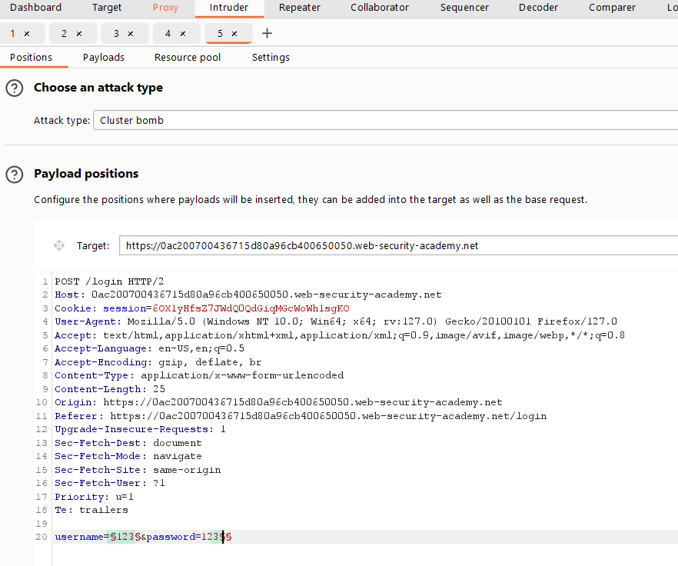

We are using cluster bomb and in password we don’t need 123 but if we remove everything that parameter show missing values

Let go to payloads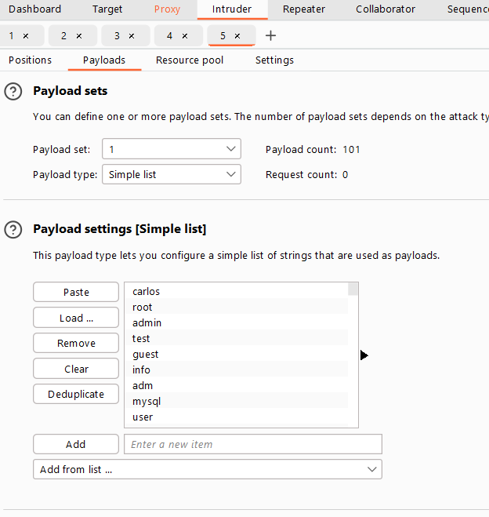

In 1st one adds username give list.

And in 2nd One we are going to use null payloads

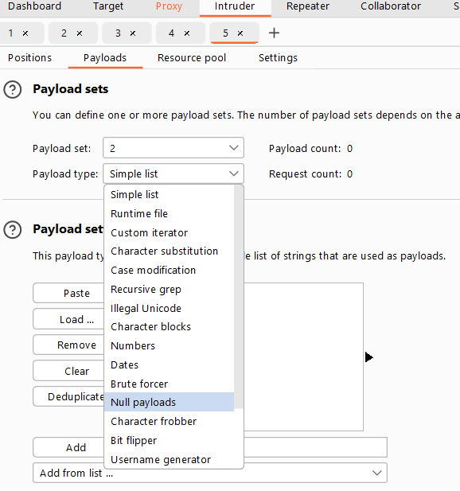

Generate 5 bez it enough , it combine null value and password “123”

Together

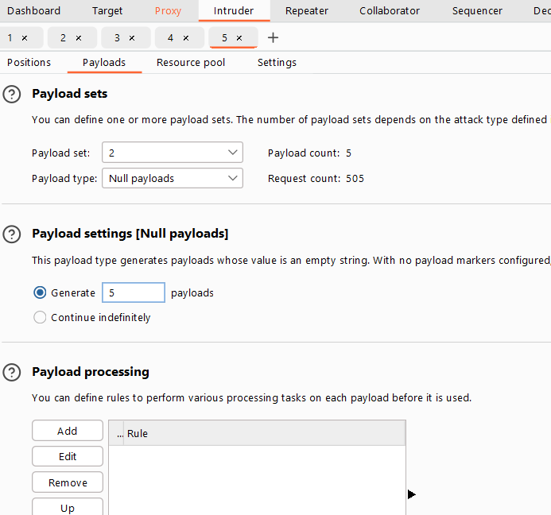

it will try ever username in list with 5 time to see if we get an account lock

**Let Start Attack**

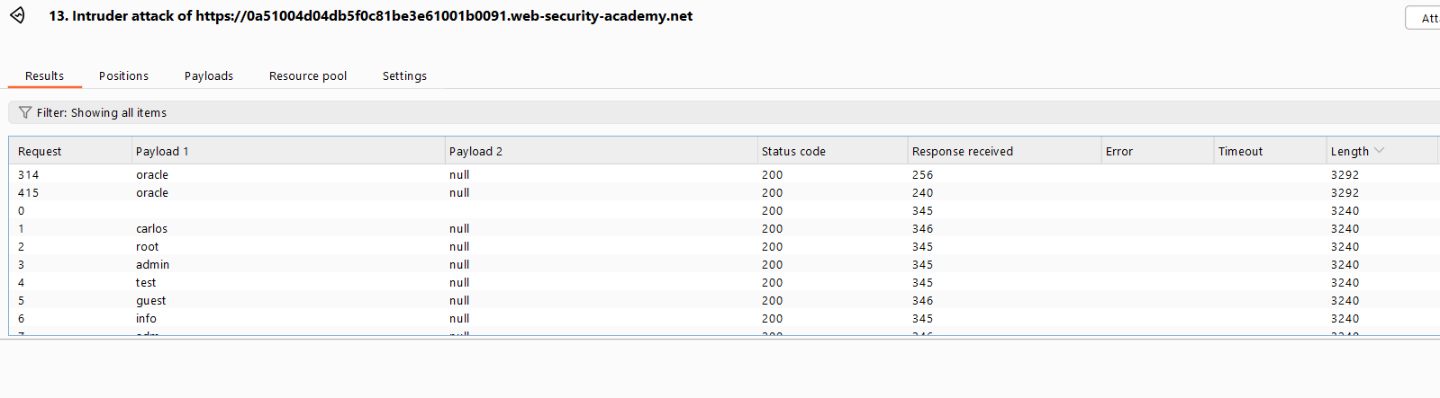

**We get a different length**

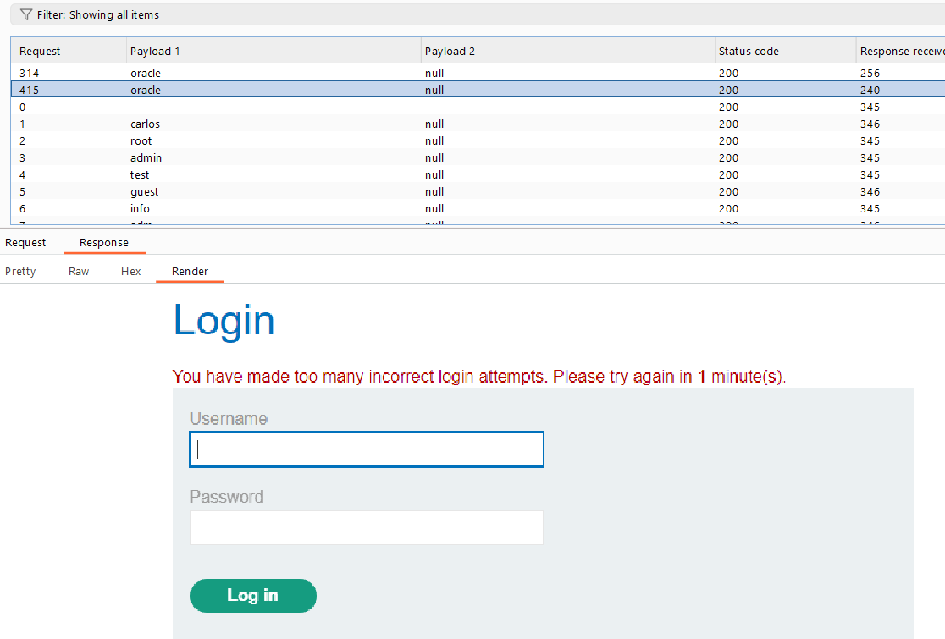

**And this account get locked**

**Send this request to Intruder,**

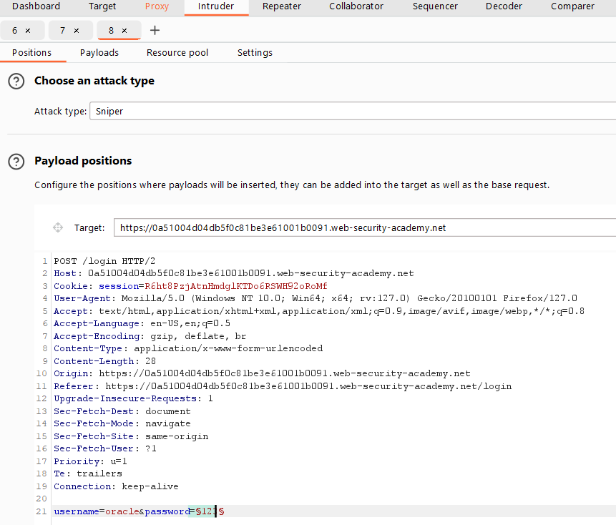

**In payload position add password list**

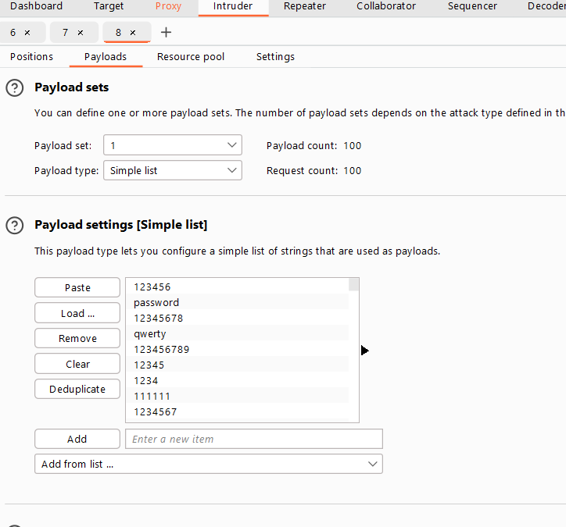

**Start Attack**

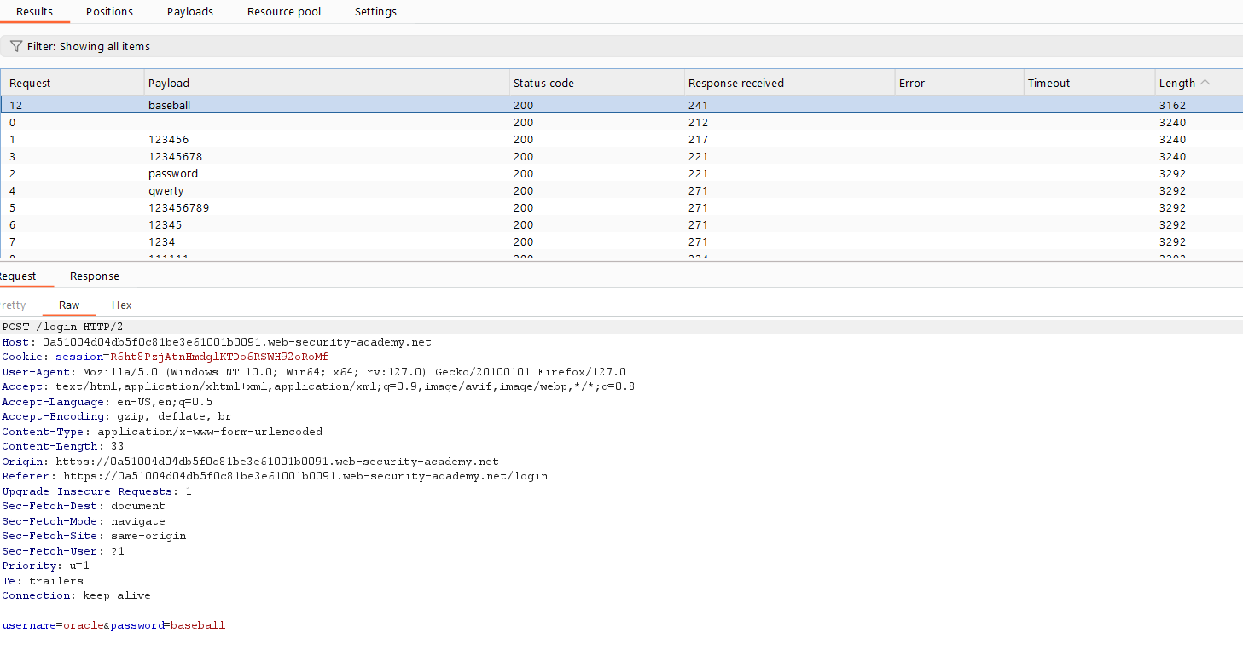

**We get a different length**

**Let Login**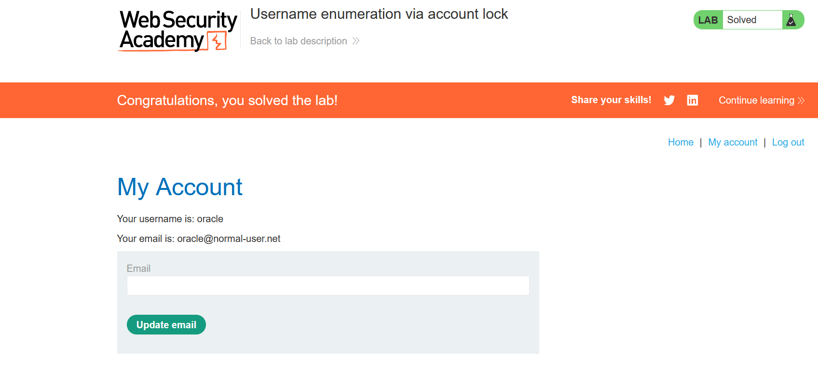

**Done**

# Method: 4. User rate limiting

Another way websites try to prevent brute-force attacks is through user rate limiting. In this case, making too many login requests within a short period of time causes your IP address to be blocked. Typically, the IP can only be unblocked in one of the following ways:

• Automatically after a certain period of time has elapsed

• Manually by an administrator

• Manually by the user after successfully completing a

CAPTCHA.

User rate limiting is sometimes preferred to account locking due to being less prone to username enumeration and denial of service attacks. However, it is still not completely secure. As we saw an example of in an earlier lab, there are several ways an attacker can manipulate their apparent IP in order to bypass the block.

As the limit is based on the rate of HTTP requests sent from the user's IP address, it is sometimes also possible to bypass this defense if you can work out how to guess multiple passwords with a single request.

# Method: 4. Lab: 6. Broken brute-force protection, multiple credentials per request.

<https://portswigger.net/web-security/authentication/password-based/lab-broken-brute-force-protection-multiple-credentials-per-request>

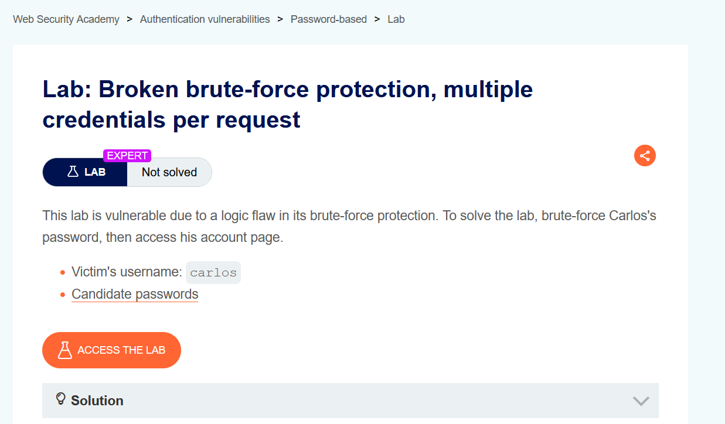

In this lab scenario we already victim username: Carlos,

And we have a list of passwords. We can’t brute-force directly

More than 3 attempts can block our Ip temporarily.

**Let Access the lab**

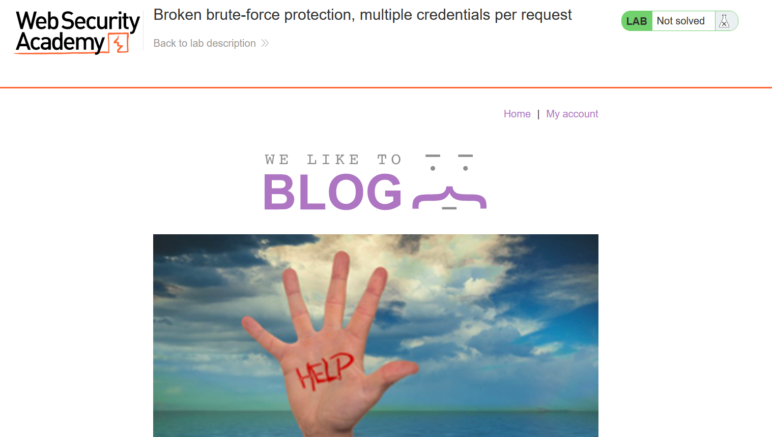

**To go > my account**

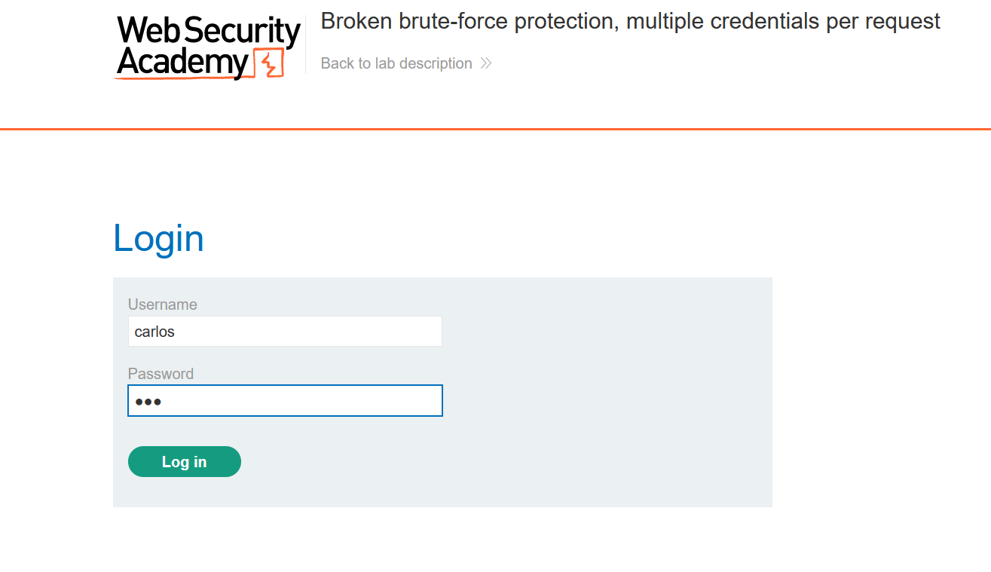

**Let capture this Request**

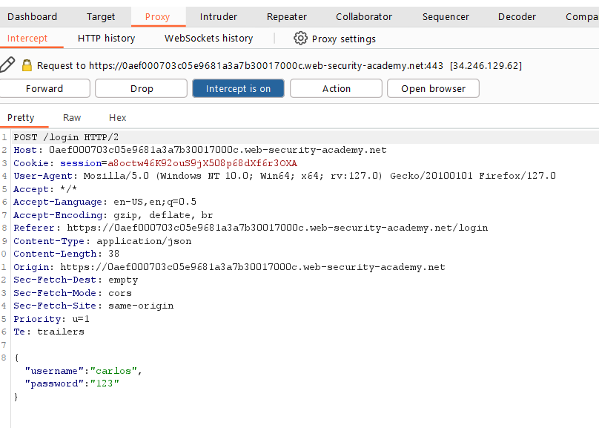

This Request is different than the last labs we saw

It looks like JSON Format is in use... Let send this to repeater

To observer more.

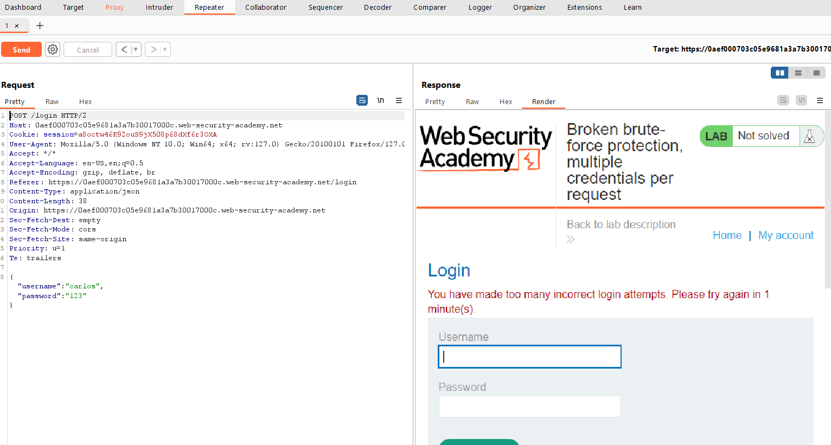

After 3 attempts I got blocked temporarily.

I try to add X-forwarded-for header to bypass

IP-protection, but it’s not work.

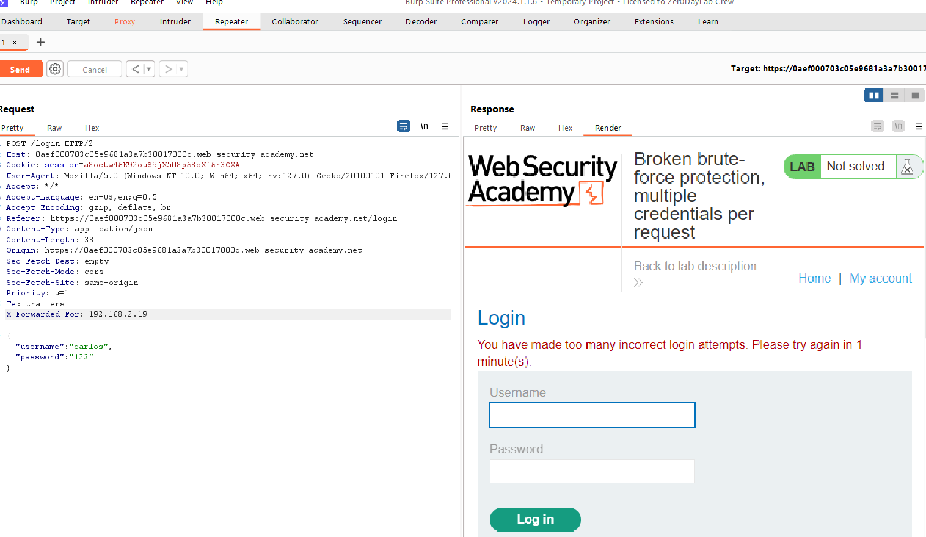

So, what we need to add let copy all password/

Create an array in burp repeater, replace the single string value of the password with an array of strings containing all of the candidate passwords. For example:

"username" : "carlos",

"password" : [

"123456",

"password"

"qwerty"

...

]

So, let Arrange all password in this manner

"123456",

"password",

"12345678",

"qwerty",

"123456789",

"12345",

"1234",

"111111",

"1234567",

"dragon",

"123123",

"baseball",

"abc123",

"football",

"monkey",

"letmein",

"shadow",

"master",

"666666",

"qwertyuiop",

"123321",

"mustang",

"1234567890",

"michael",

"654321",

"superman",

"1qaz2wsx",

"7777777",

"121212",

"000000",

"qazwsx",

"123qwe",

"killer",

"trustno1",

"jordan",

"jennifer",

"zxcvbnm",

"asdfgh",

"hunter",

"buster",

"soccer",

"harley",

"batman",

"andrew",

"tigger",

"sunshine",

"iloveyou",

"2000",

"charlie",

"robert",

"thomas",

"hockey",

"ranger",

"daniel",

"starwars",

"klaster",

"112233",

"george",

"computer",

"michelle",

"jessica",

"pepper",

"1111",

"zxcvbn",

"555555",

"11111111",

"131313",

"freedom",

"777777",

"pass",

"maggie",

"159753",

"aaaaaa",

"ginger",

"princess",

"joshua",

"cheese",

"amanda",

"summer",

"love",

"ashley",

"nicole",

"chelsea",

"biteme",

"matthew",

"access",

"yankees",

"987654321",

"dallas",

"austin",

"thunder",

"taylor",

"matrix",

"mobilemail",

"mom",

"monitor",

"monitoring",

"montana",

"moon",

"moscow"

**It look kind a like this:**

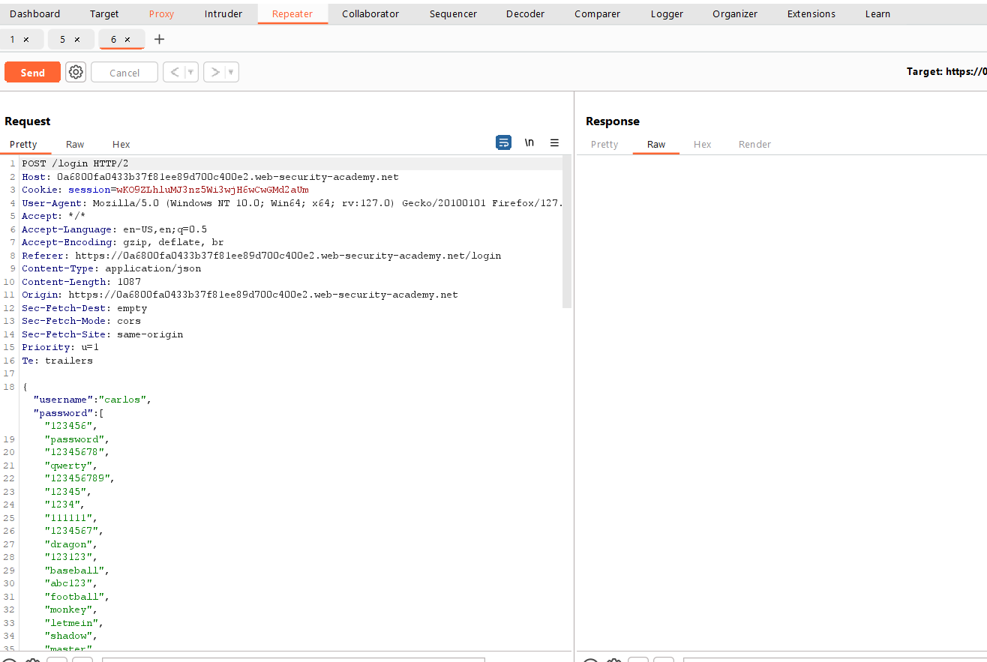

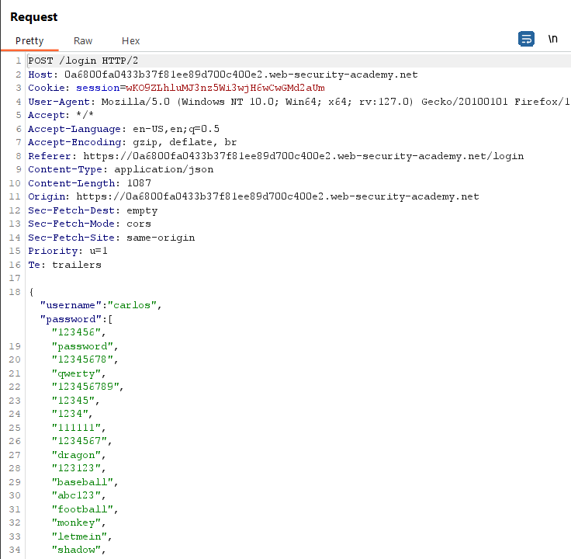

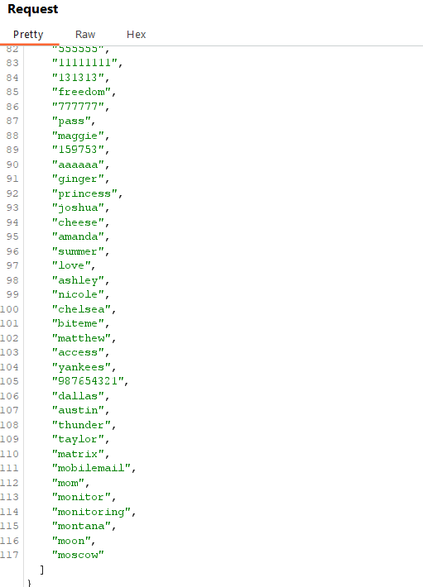

**Send this edited request to see the response:**

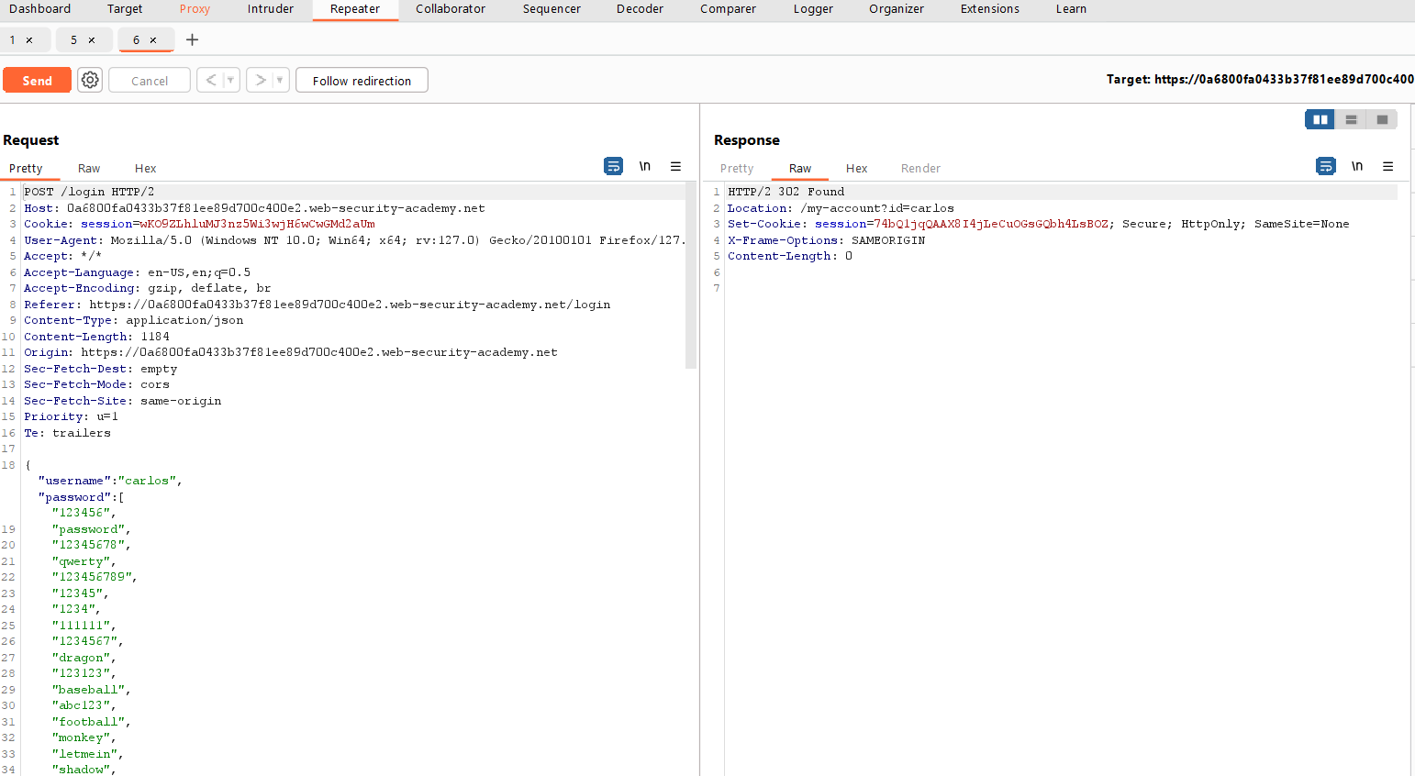

**We got it but we don’t know password**

**So, let just request this in browser session. I’m requesting in original.**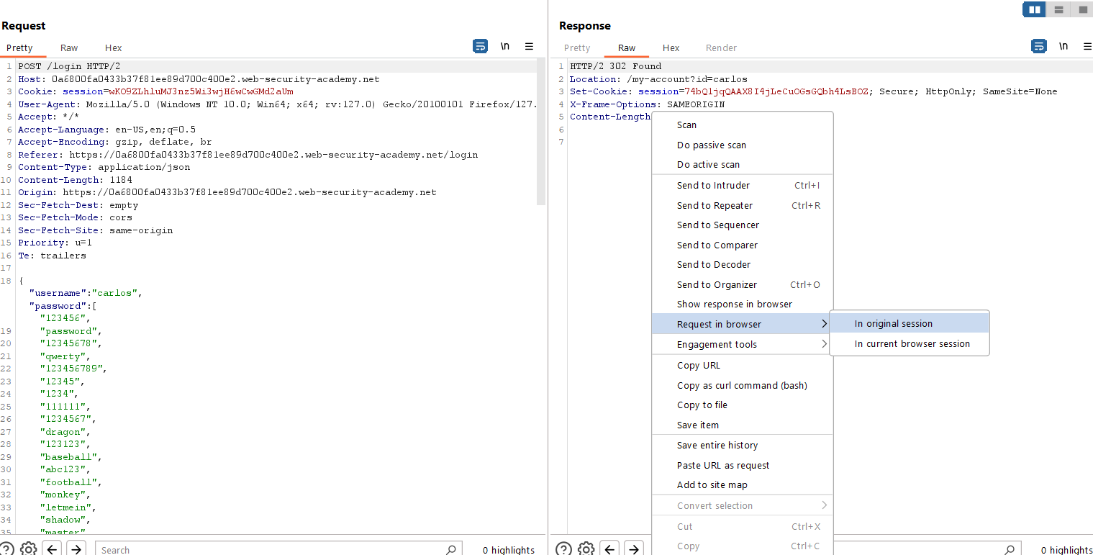

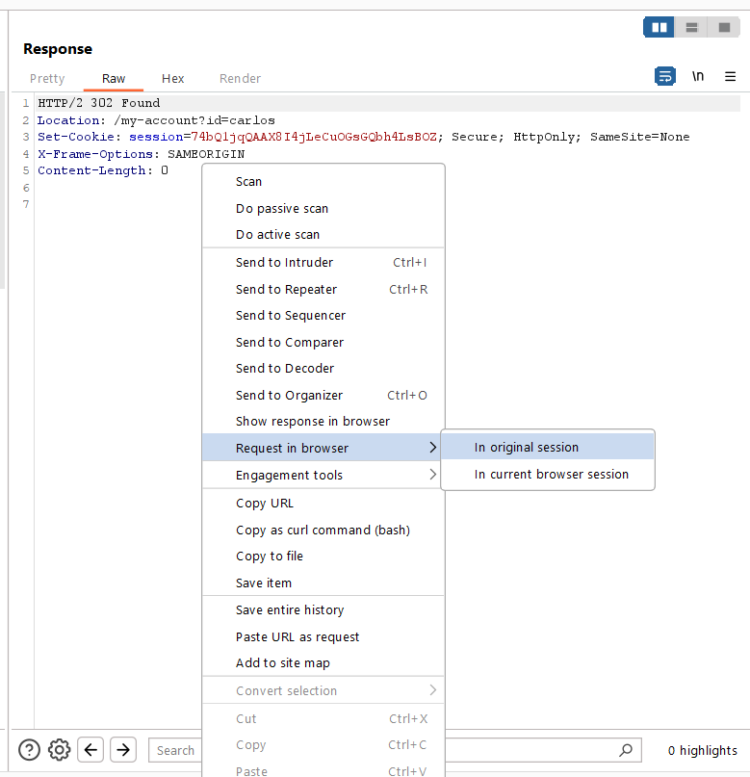

**Copy the URL**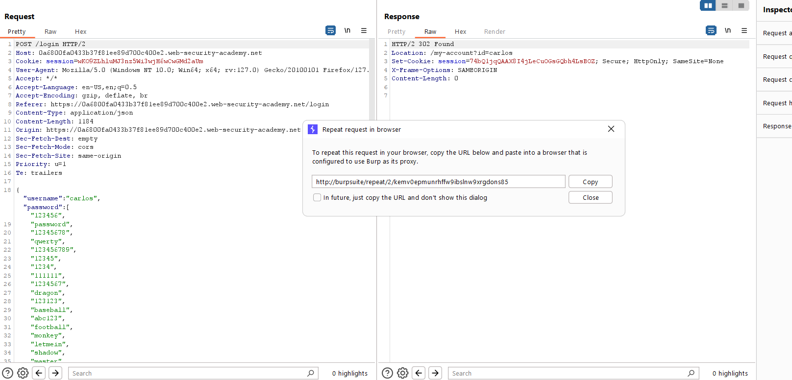

**Past In browser**

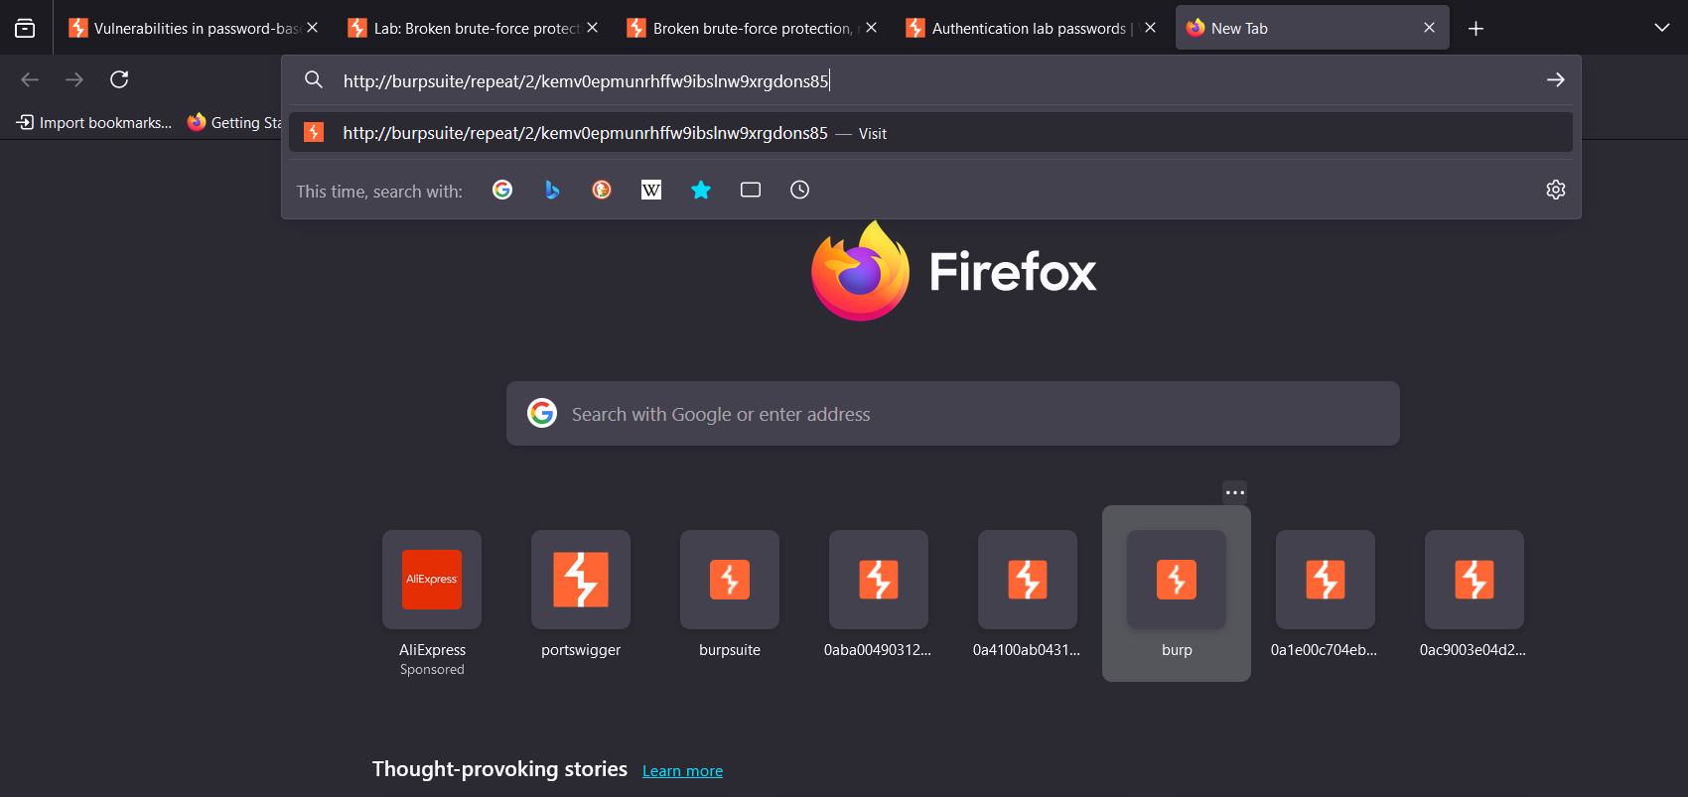

**If u enter you see a page like this**

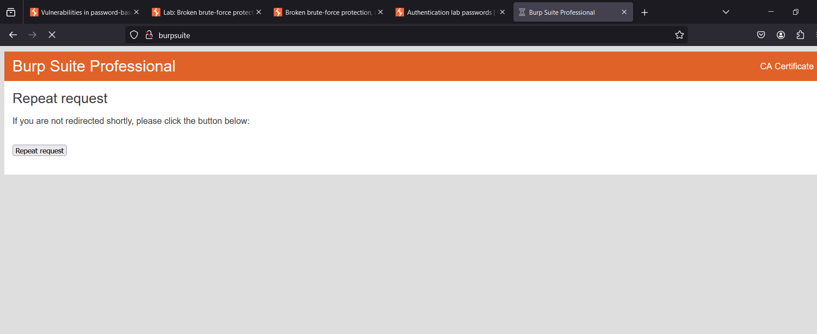

**Then go to Burp:**

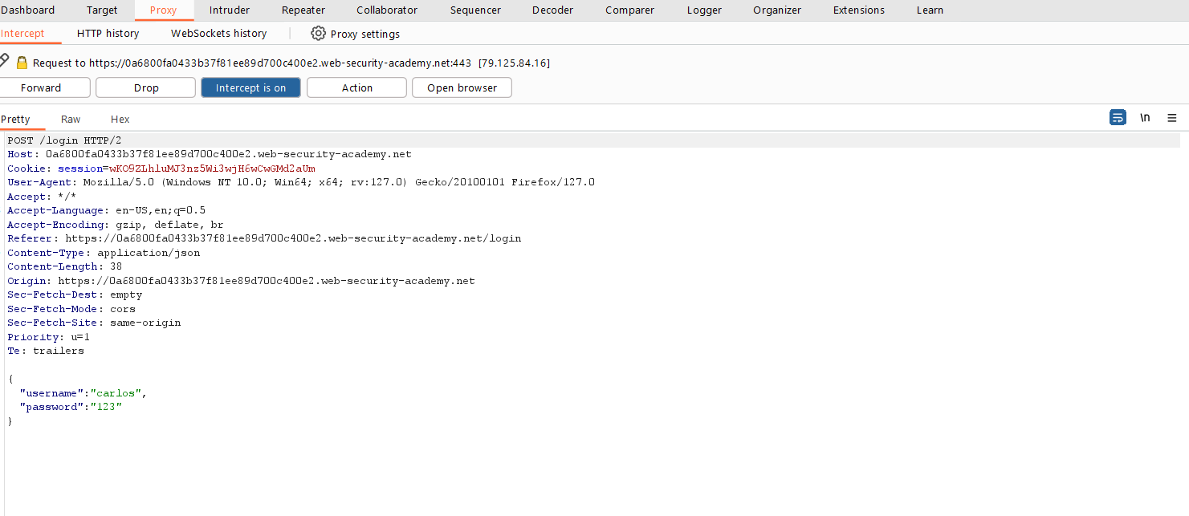

**Forward all the request :**

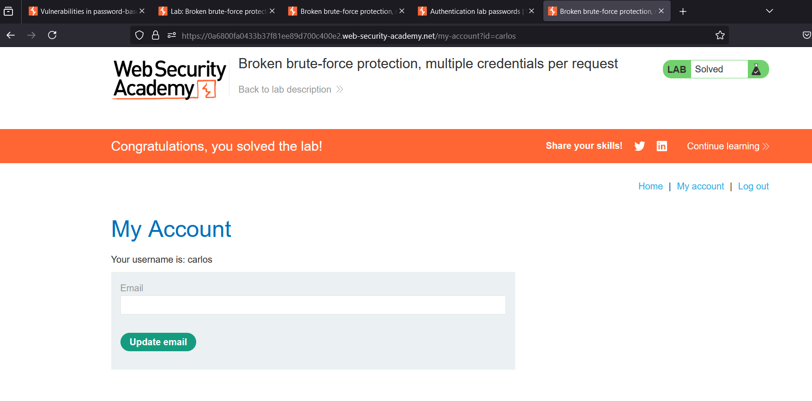

**Done**

# Method: 5. HTTP basic authentication

Although fairly old, its relative simplicity and ease of implementation means you might sometimes see HTTP basic authentication being used. In HTTP basic authentication, the client receives an authentication token from the server, which is constructed by concatenating the username and password, and encoding it in Base64. This token is stored and managed by the browser, which automatically adds it to the Authorization header of every subsequent request as follows:

Authorization: Basic base64(username:password)

For a number of reasons, this is generally not considered a secure authentication method. Firstly, it involves repeatedly sending the user's login credentials with every request. Unless the website also implements HSTS, user credentials are open to being captured in a man-in-the-middle attack.

In addition, implementations of HTTP basic authentication often don't support brute-force protection. As the token consists exclusively of static values, this can leave it vulnerable to being brute-forced.

HTTP basic authentication is also particularly vulnerable to session-related exploits, notably CSRF, against which it offers no protection on its own.

In some cases, exploiting vulnerable HTTP basic authentication might only grant an attacker access to a seemingly uninteresting page. However, in addition to providing a further attack surface, the credentials exposed in this way might be reused in other, more confidential contexts.

# Vuln 2: Vulnerabilities in multi-factor authentication